**____________________________**

**JOB RECRUITMENT SYSTEM**

**____________________________**

**TABLE OF CONTENTS**

|  |  |  |
| --- | --- | --- |
| Chapter | Title | Page |
| 1 | Introduction | 3-4 |
| 2 | Preface | 5 |
| 3 | System Design | 6 |
| 4 | Planning | 7 |
| 5 | Feasibility Study | 8 |
| 6 | Project Designing | 9-15 |
| 7 | Data Dictionary Model | 16-18 |
| 8 | Form Designs | 19-33 |
| 9 | Form Codings | 34-58 |
| 10 | Conslusion | 59 |
| 11 | Biblography | 60 |

**___________________________**

**INTRODUCTION**

**___________________________**

## ****INTRODUCTION****

Job portal is an application which connects employer and job seekers where employers are the source of the resources and the job seeker can find and apply for their targeted job. This document provides details about the entire software requirement specification for the online job portal. Jobs are necessary for each and every individual after students finishes their education. Without any job will make a person lazy.  You can see these days that many job portals come up which gives information of the jobs that are available in different parts of the country and in different fields. The online job portal is one of the projects which accomplish this task. It will provide the information like the jobs that will be available in different fields and also different parts of the country. Through this the jobseekers can have an easy search of their jobs online.

People search for the opportunities by going to the offices of the organizations and asking them for the vacancies. This will be time consuming, waste of money, fuel etc. You can go to the companies only when there are vacancies there. You can get to know of the vacancies in different companies through online job portal. The online job portal must be having a strong database since many job vacancies need to update from time to time. If the particular job vacancy has been expired even that also must be updated. The features that the online job portal can include are as follows:

* **Login separately for the employer and the job seeker**: There will be separate login must be provided separately for the employers and the job seekers.
* **Premium membership**: This job portal can have the facility of the premium membership through which you can gain profit.
* **Search option**: There will be search option provided through which the search of jobs can taken place.
* **Various categories**: The jobs can be classified based on IT jobs, Bank jobs, BPO jobs, Accounting jobs and many more. Further it can be also categorized based on the different regions in India or outside India.

This will be one of the interesting applications that one can work on and implement in real time world with great ease and without any difficulty. This application can ensure the users in providing the jobs as per the qualifications and experience that they have without any difficulty. This application will be very efficient and easy to use even by the common man. This application can give you information related to the jobs that are available in all over the world without any difficulty. The features that can be included in the online job site documentation are as follows:

* **Easy access**: This application can be accessed anytime and anywhere from the world.
* **User friendly**: This application will be user friendly since the user interface will be simple and easy to understand even by the common man.
* **Reliability**: This will be one of the applications which can be relied on in order to search for the jobs without any difficulty.

**___________________________**

**PREFACE**

**___________________________**

## ****PREFACE****

* This Job Portal website is providing to the online job portal system.
* This website can be also providing information about online job.
* The customer can get the online registration.
* The Job Portal web application can be used by any employee to apply job and any employer are post to job.

## ****Drawback of Existing system****

* Existing system are a failing in providing quick operation
* Cost is high as well.
* Processing very lengthy and time consuming.
* More time consume for before generation.

## ****Need for new System****

1. Proposed Job Portal system consists of 3 modules: Job Seeker, Employer and Administrator.
2. Online Job Portal will provide the fast operation and low cost expense than old system.
3. Easy job search, which is a job seeker need

## ****Software Requirement****

1. Operating System : Windows / Linux / MacOS
2. Front End : HTML, Java Script, PHP, CSS
3. Back End : PHP, MYSQL
4. Supporting Server : Xampp

## ****Hardware Requirement****

1. Processor : Intel Pentium IV,2.4 GHz
2. RAM : 512 MB
3. Hard Disk Drive : 40 GB
4. Video : 800*600,1024*768 256 colors

**___________________________**

**SYSTEM DESIGN**

**___________________________**

**SYSTEM DESIGN**

If you looking for Online Job Site Project Report then this is the right place. Here you can download Complete Online Job Site Project Report. Jobs are very essential for each and every one of us living in this society. People without jobs will be seen in different way or treated differently. There will be many students all over the world who graduate each year from various branches and domain. But the availability of the jobs will be less than the number of the people who are being graduated every year. Some people get selected through the campus placements, some just take forward their family business, some go for higher studies etc. People who do not get selected through the campus placements find it difficult to find jobs. What if there is an application that can ease such task? Yes, it is possible through the use of online job site report application.

The online job site report is an application that can allow the user to search for the job availability all over the world. They can categorize the search for the jobs through this application with great ease. People can rely on this application for the job search without any difficulty. The user interface will be simple and easy to understand even by the common man with great ease and without any difficulty. This application can also provide the report regarding the jobs that one has searched for with great ease.

The features that can be included in the online job site report application are as follows:

* **Vacancies**: This application can give you the detailed information related to the vacancies that are present in all over the world with great ease.
* **Saves time**: This application can help in saving time since there is no need to go personally go to the companies in order to ask about the job vacancies.
* **Ease of access**: This application will be very easy to access anywhere from the world.

**___________________________**

**PLANNING**

**___________________________**

**PLANNING**

**DEFINING THE PROBLEM**

1. It was difficult to maintain the records of each and every member manually.
2. The admission process was time consuming.
3. Manual work can cause human error.
4. Maintaing records of various facilities used by a particular member was difficult.
5. Handling of files & paper was difficult and their was chance of misplacing it.

**ANTICIPATED BENEFITS**

1. The database of each member will be maintained systematically.
2. It will keep the track records of various facilities used by a particular member.
3. The admission procedure will be faster and receipt will be generated instantly.
4. It will maintain attendance of staff members.

**___________________________**

**FEASIBILITY STUDY**

**___________________________**

**FEASIBLITY STUDY**

The very first phase in a system developing life cycle is preliminary investigation. The feasibility study is a major part of this phase. A measure of how beneficial or practical the development of any information system would be to the organization is the feasibility study.

Our study of the feasible development of the software is going to be in terms of following steps:

1. **ECONOMIC FEASIBILTY**

It is used to determine the development cost and the anticipated benefits of the systems and system budget should not exceed the client budget .

* **Tangible Benefits**

1. It will be less time consuming.
2. The system can be handle by a single person so staff can be reduced
3. The cost on stationary such as measurement card, admission form can be reduced

* **Intangible Benefits**

1. The satisfaction of members will be more.
2. A good interaction between member and staff.
3. Inrease level of service
4. **SCHEDULING FEASIBILITY**

* To complete the project, phase wise in allocated time.
* To complete the each phase in time so that project can be completed in deadline.
* After scheduling comparison can be made to see whether timetable coincides, if not corrective measure can be taken, such as reducing scope of the project.

**___________________________**

**PROJECT DIAGRAM’S**

**___________________________**

**PROJECT DIAGRAMS**

**EVENT PARTITION**



**DECOMPOSITION**

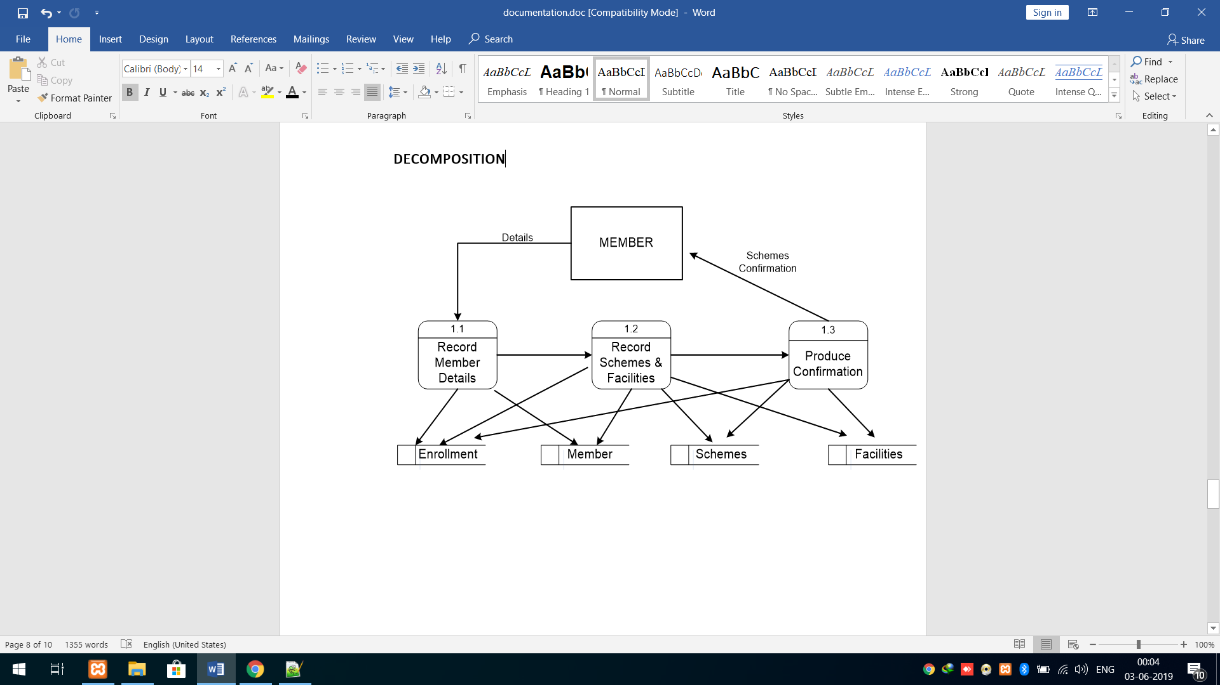

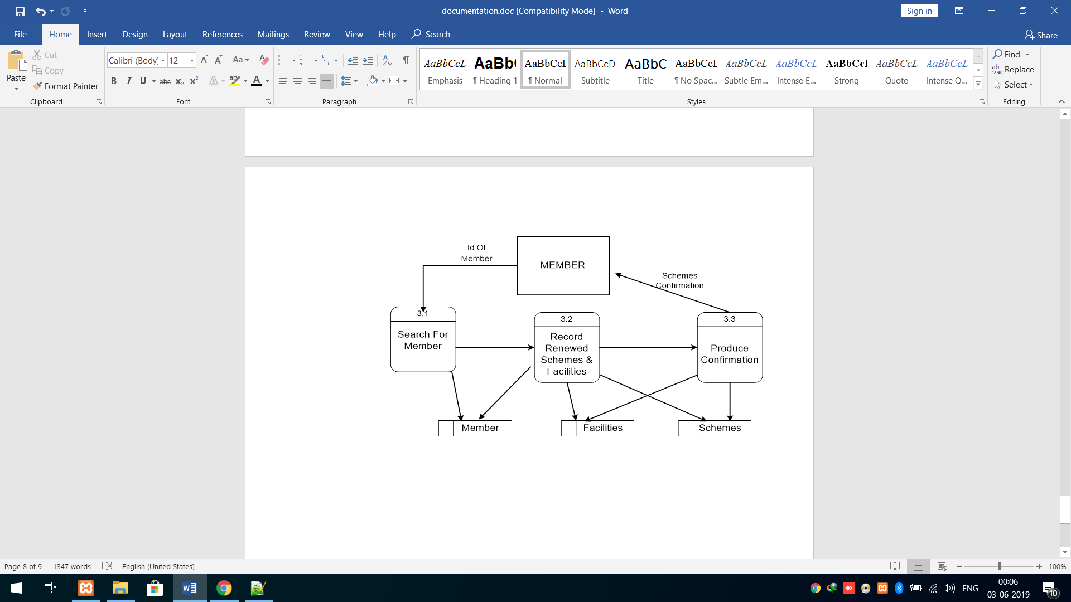

**CONTEXT LEVEL DIAGRAM**

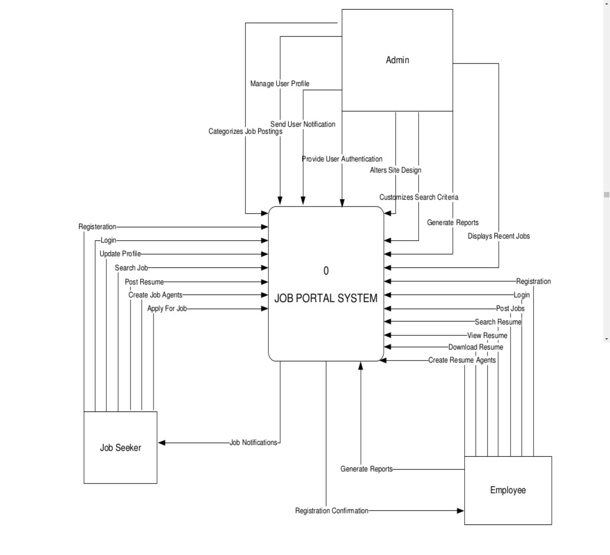

**DATA FLOW DIAGRAM**

1. **Company (Employer)**

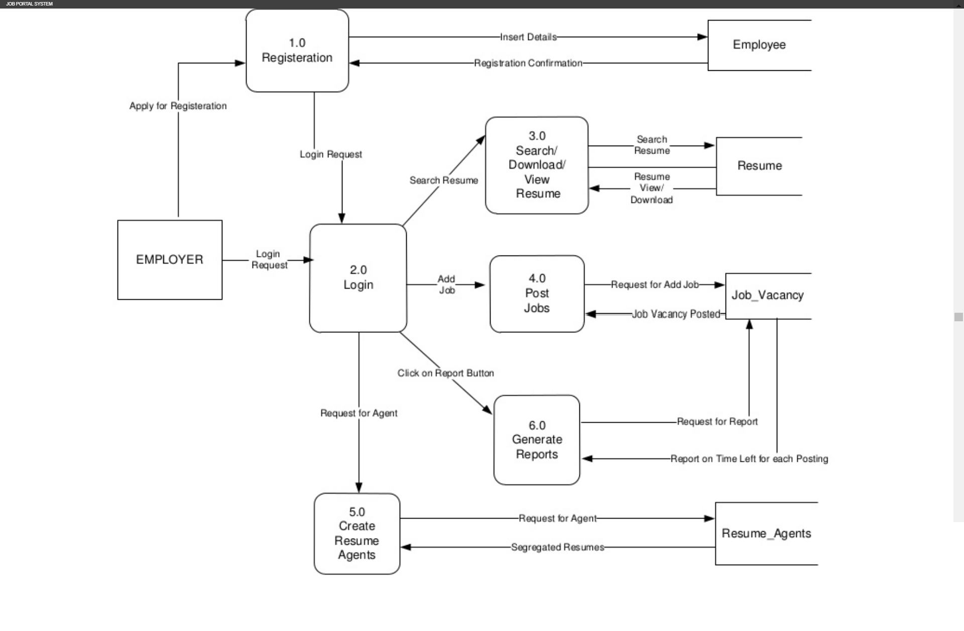

1. **Candidate (Job Seeker)**

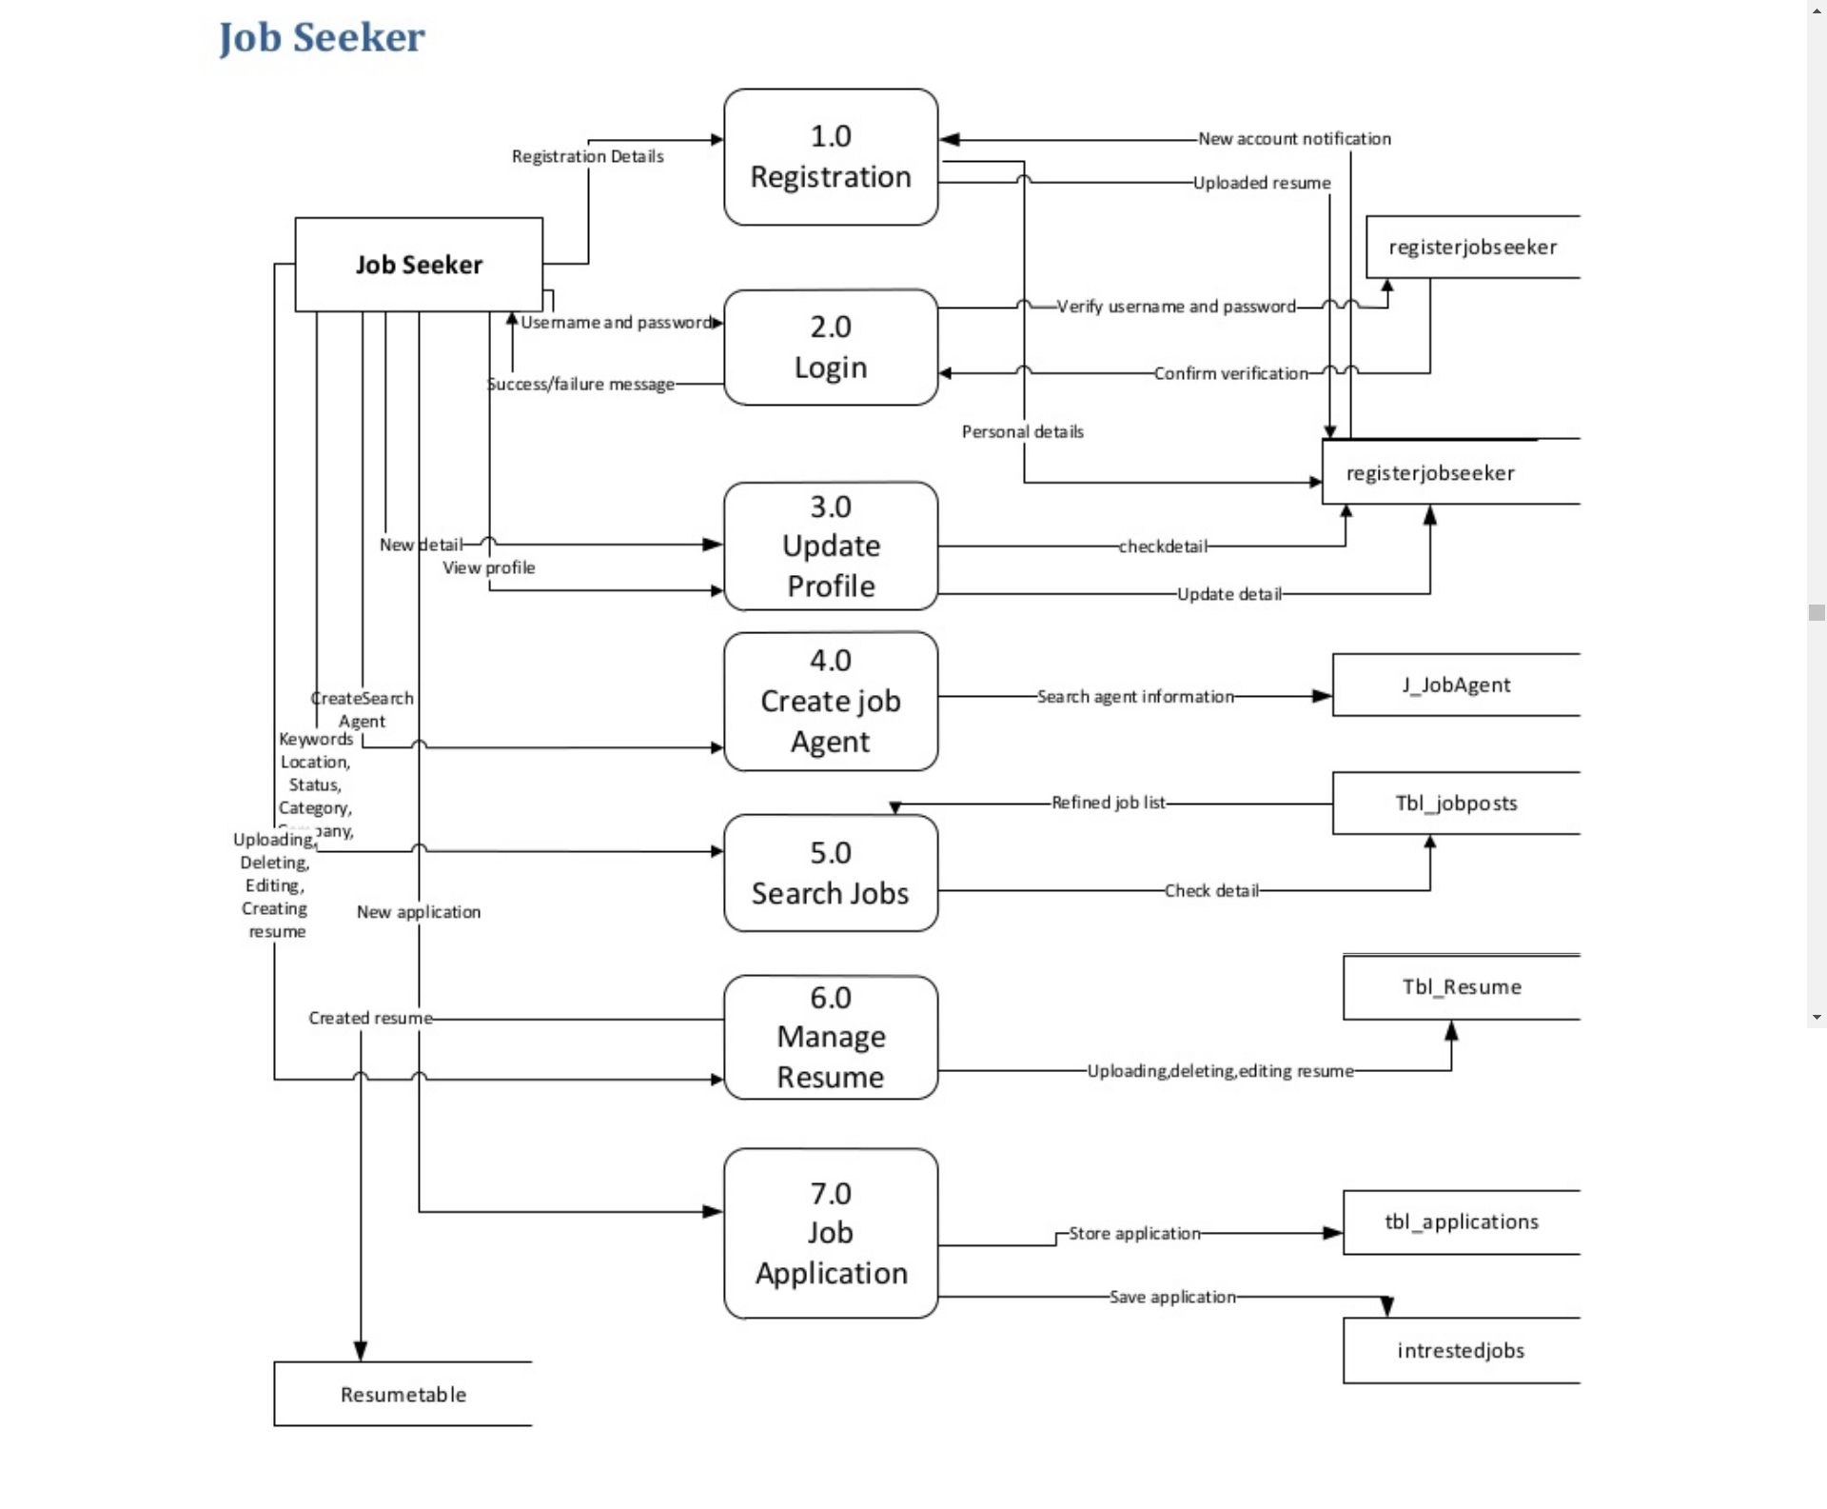

1. **Admin**

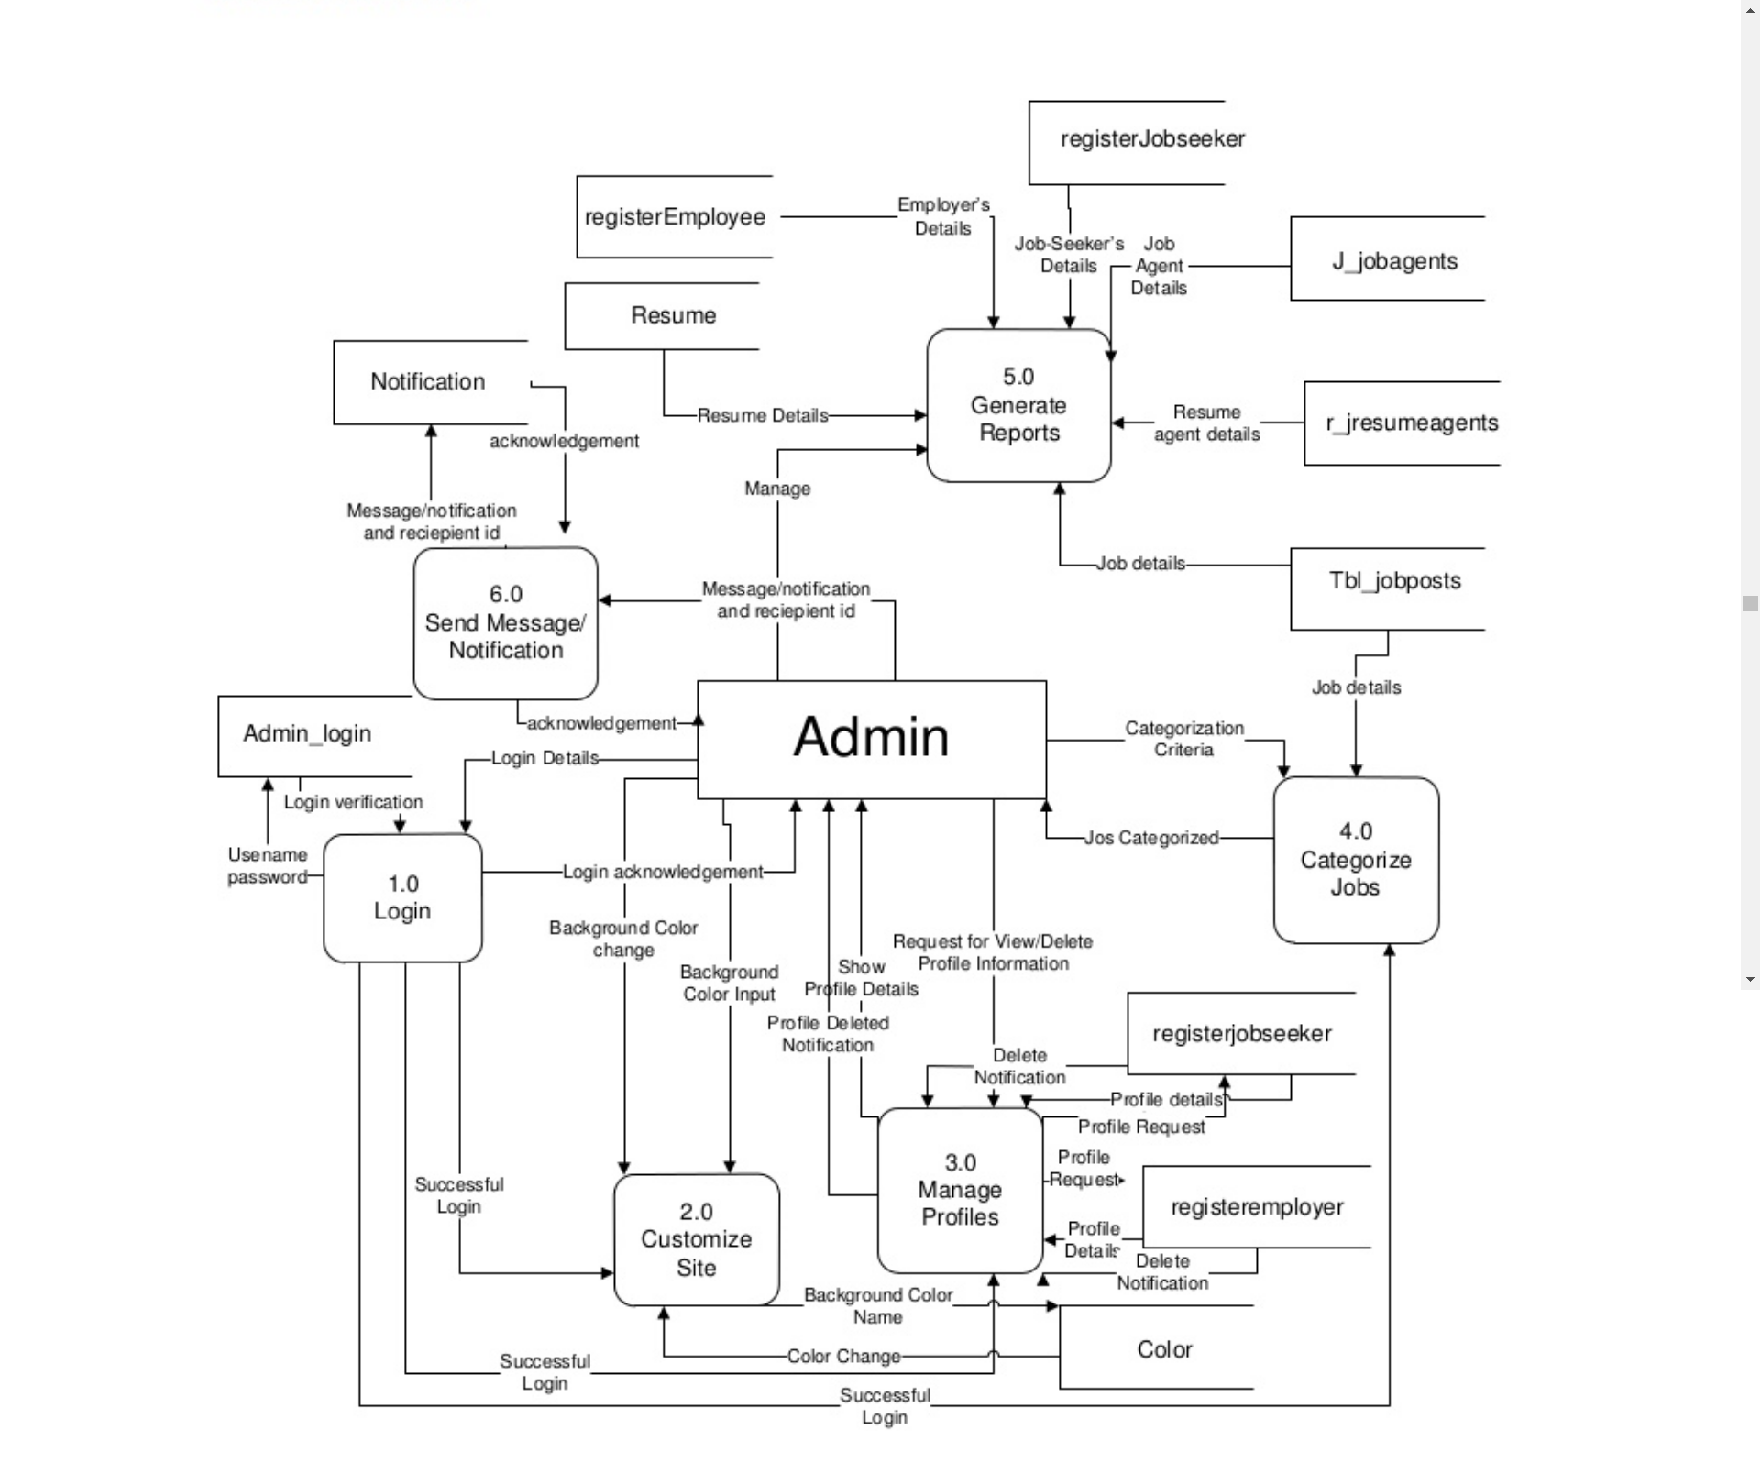

**ER DIAGRAM**

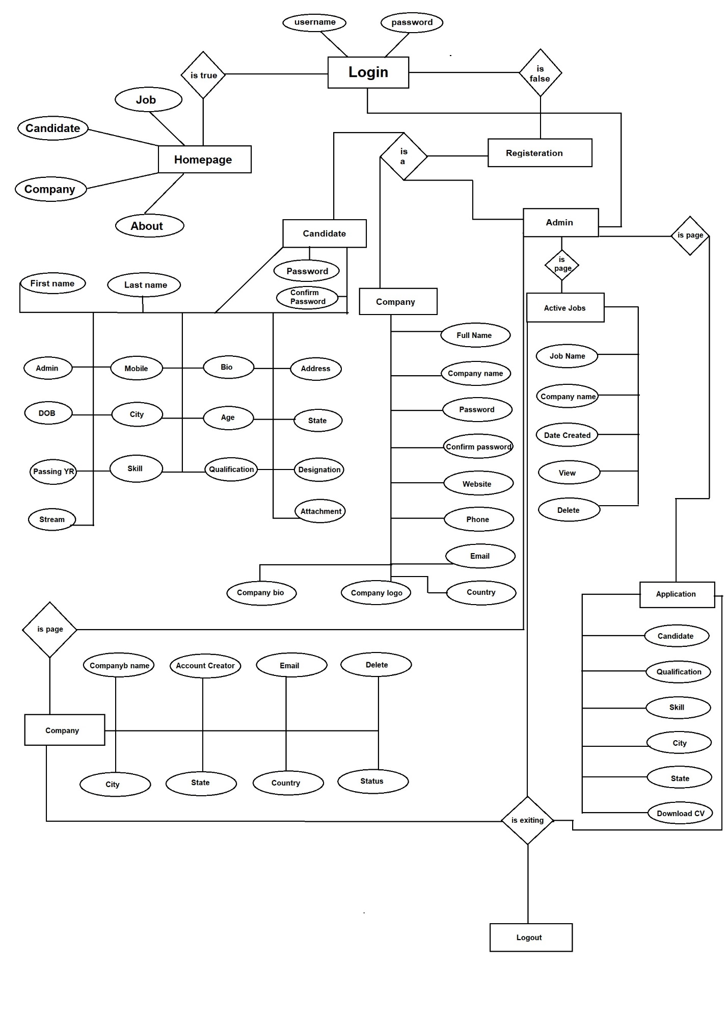

**___________________________**

**DATA DICTIONARY**

**___________________________**

**DATABASE DESIGN**

1. Admin

|  |  |  |  |  |
| --- | --- | --- | --- | --- |
| Entity Name | Type | Null | Default | Extra |
| id_admin | varchar | no | none | Auto_Increment |
| username | varchar | no | none |  |
| passwords | varchar | no | none |  |

1. Apply Job Post

|  |  |  |  |  |
| --- | --- | --- | --- | --- |
| Entity Name | Type | Null | Default | Extra |
| id_apply | int | no | none | Auto_Increment |
| Id_jobpost | int | no | none |  |
| Id_company | int | no | none |  |
| Id_user | int | no | none |  |
| status | int | no | 0 |  |

1. Cities

|  |  |  |  |  |
| --- | --- | --- | --- | --- |
| Entity Name | Type | Null | Default | Extra |
| id | int | no | none | Auto_Increment |
| name | varchar | no | none |  |
| state_id | int | no | none |  |

1. Company

|  |  |  |  |  |
| --- | --- | --- | --- | --- |
| Entity Name | Type | Null | Default | Extra |
| Id_company | int | no | none | Auto_Increment |
| name | varchar | no | none |  |
| companyname | varchar | no | none |  |
| state | varchar | no | none |  |
| city | varchar | no | none |  |
| contactno | int | no | none |  |
| website | varchar | no | none |  |
| email | varchar | no | none |  |
| password | varchar | no | none |  |
| aboutme | varchar | yes | none |  |
| logo | varchar | no | current_timestamp |  |
| createdAt | time | no | none |  |
| active | int | no | 2 |  |

1. Countries

|  |  |  |  |  |
| --- | --- | --- | --- | --- |
| Entity Name | Type | Null | Default | Extra |
| id | int | no | none | Auto_Increment |
| sortname | varchar | no | none |  |
| name | varchar | no | none |  |
| phonecode | int | no | none |  |

1. Job_post

|  |  |  |  |  |
| --- | --- | --- | --- | --- |
| Entity Name | Type | Null | Default | Extra |
| Id_jobpost | int | no | none | Auto_Increment |
| Id_company | int | no | none |  |
| jobtitle | varchar | no | null |  |
| Description | varchar | no | none |  |
| minimumsalary | int | no | none |  |
| maximumsalary | int | no | none |  |
| experience | int | no | none |  |
| qualification | varchar | no | none |  |
| createdat | time | no | Current_timestamp |  |

1. Mailbox

|  |  |  |  |  |
| --- | --- | --- | --- | --- |
| Entity Name | Type | Null | Default | Extra |
| Id_mailbox | int | no | none | Auto_Increment |
| Id_fromuser | int | no | none |  |
| fromuser | varchar | no | none |  |
| Id_touser | int | no | none |  |
| subject | varchar | no | none |  |
| message | varchar | no | none |  |
| createdat | time | no | Current_timestamp |  |

1. Reply_Mailbox

|  |  |  |  |  |
| --- | --- | --- | --- | --- |
| Entity Name | Type | Null | Default | Extra |
| Id_reply | int | no | none | Auto_Increment |
| Id_mailbox | int | no | none |  |
| Id_user | int | no | none |  |
| usertype | varchar | no | none |  |
| message | varchar | no | none |  |
| createdAt | time | no | Current_timestamp |  |

1. States

|  |  |  |  |  |
| --- | --- | --- | --- | --- |
| Entity Name | Type | Null | Default | Extra |
| Id | int | no | null | Auto_Increment |
| name | varchar | no | null |  |
| country_id | int | no | 1 |  |

1. Users

|  |  |  |  |  |
| --- | --- | --- | --- | --- |
| Entity Name | Type | Null | Default | Extra |
| Id_user | int | no | none | Auto_Increment |
| firstname | varchar | no | none |  |
| lastname | varchar | no | none |  |
| email | varchar | no | none |  |
| password | varchar | no | none |  |
| address | test | yes | null |  |
| city | varchar | yes | null |  |
| state | varchar | yes | null |  |
| contactno | varchar | yes | null |  |
| qualification | varchar | yes | null |  |
| stream | varchar | yes | current_timestamp |  |
| passingyear | varchar | yes | null |  |
| dob | varchar | yes | 2 |  |
| age | varchar | yes | Default |  |
| designation | varchar | yes | null |  |
| resume | varchar | yes | null |  |
| hash | varchar | yes | null |  |
| active | int | no | none |  |

**___________________________**

**FORM DESIGNS**

**___________________________**

**FORM/PAGE DESIGNS**

1. **Homepage**

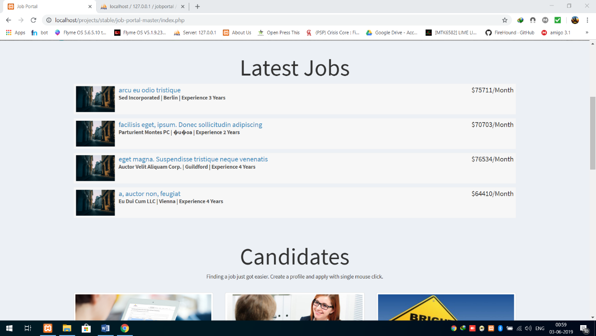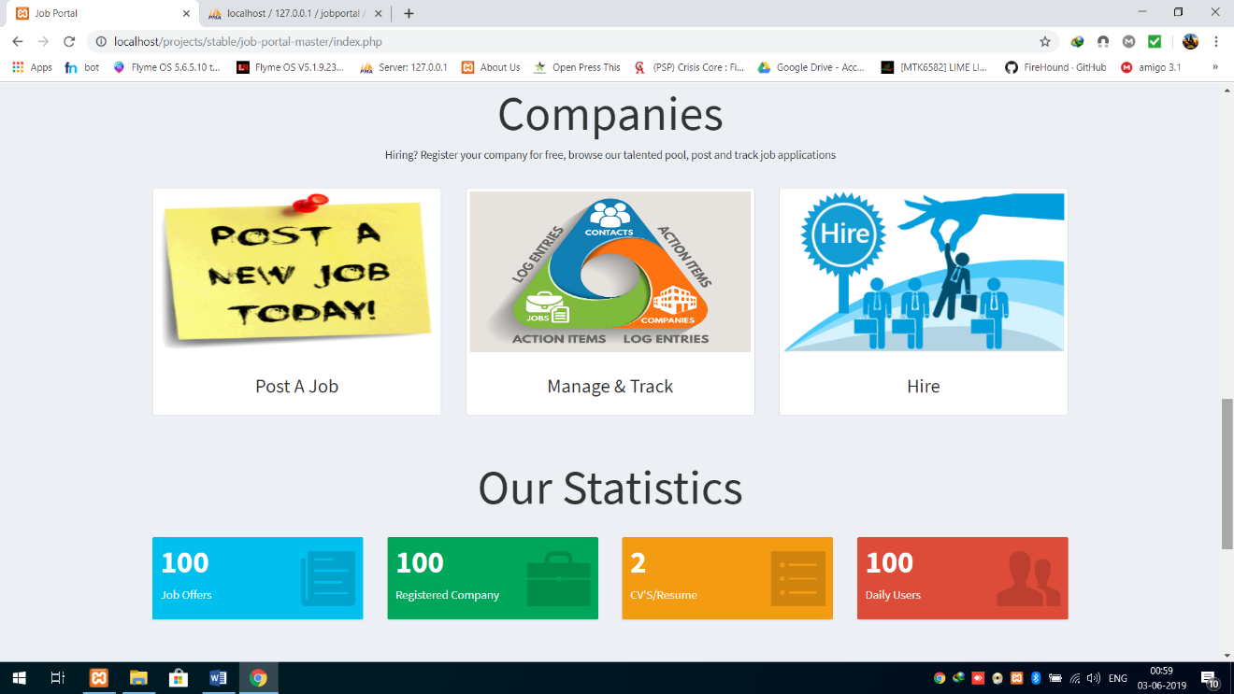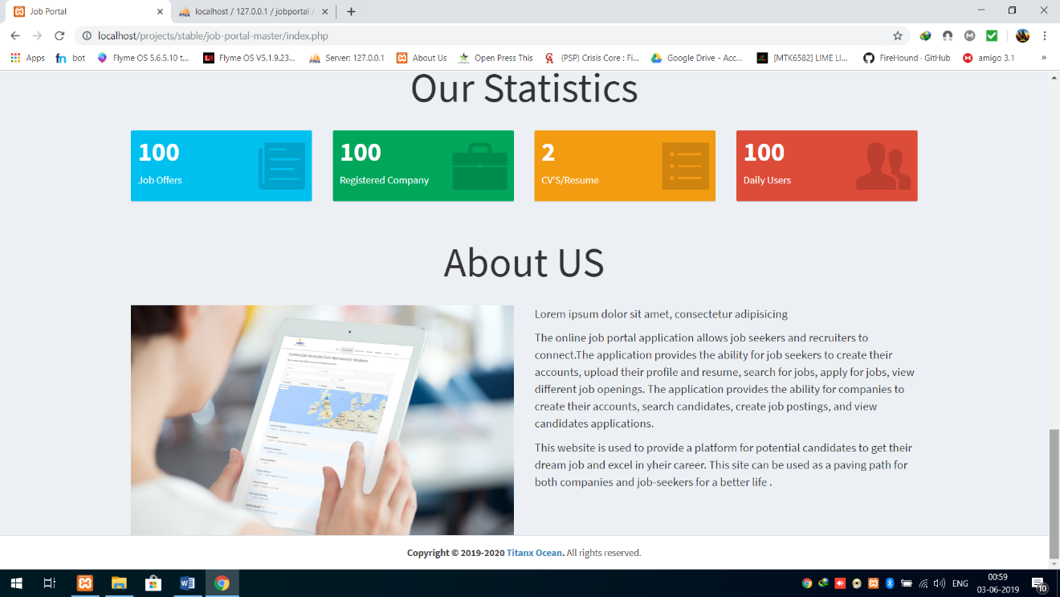

1. **Login**

Candidate Login

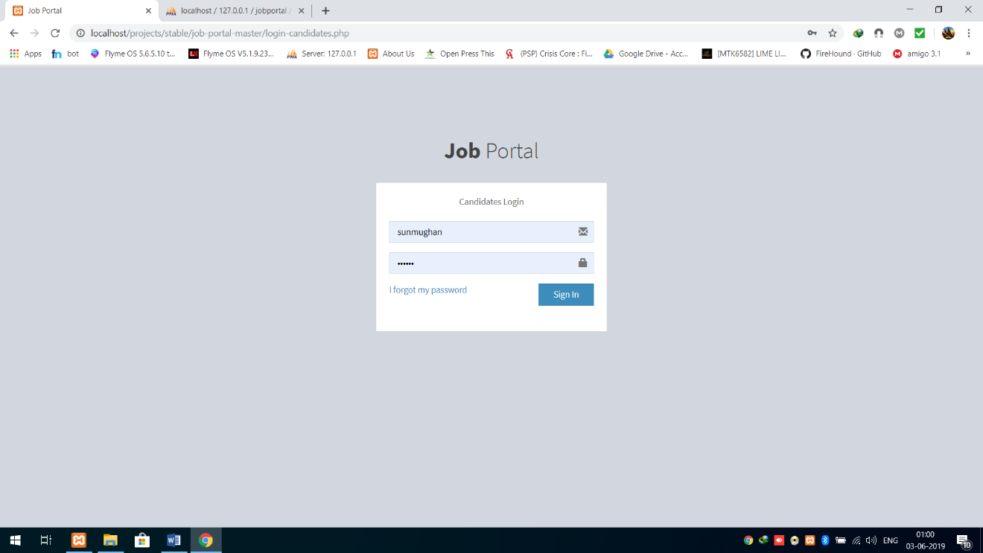

Company Login

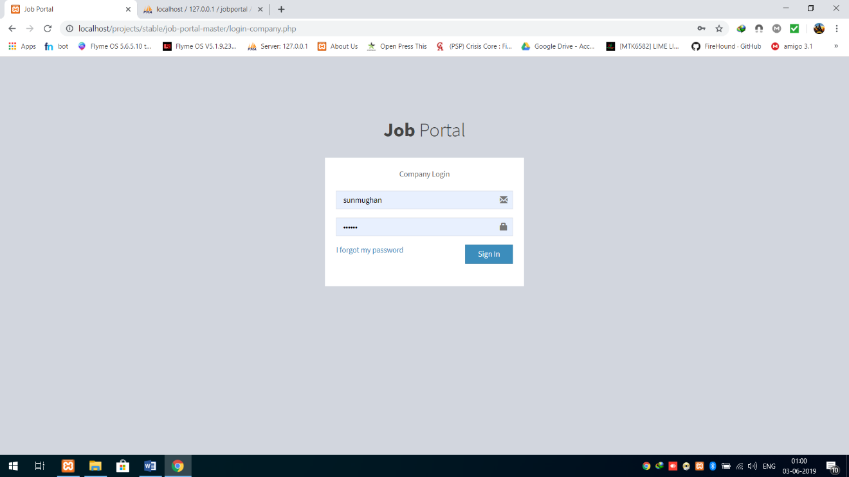

Admin Login

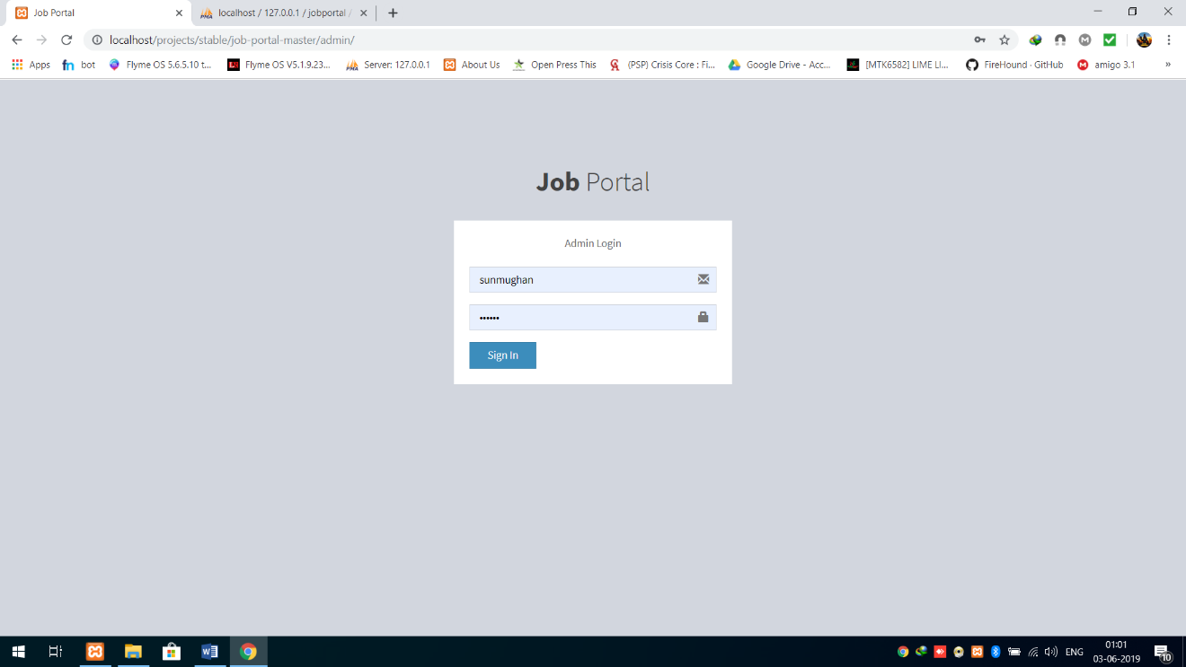

1. **Registration**

Candidate Registration

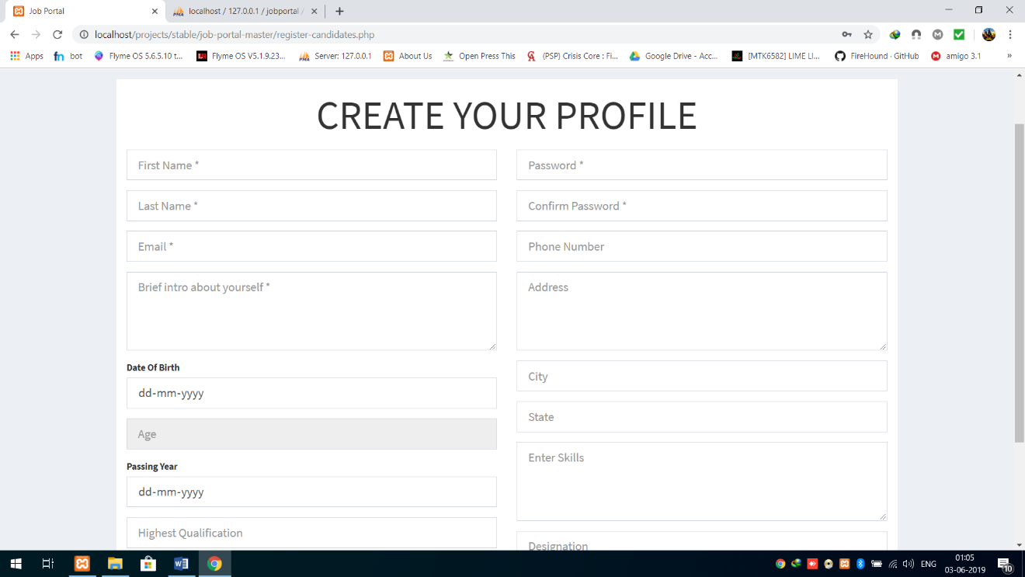

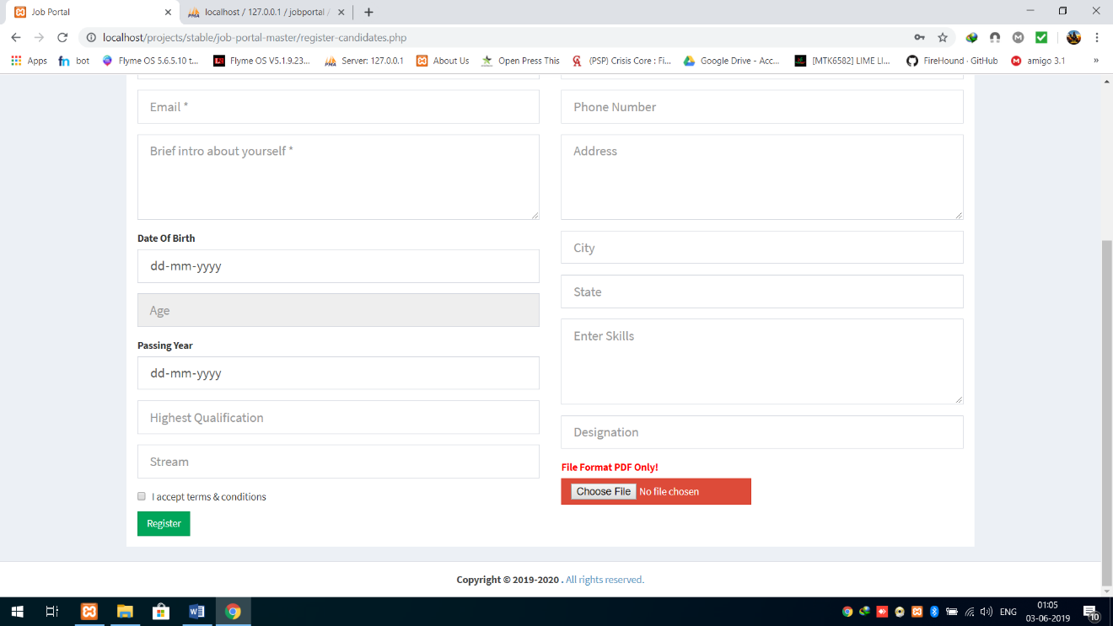

Company Registration

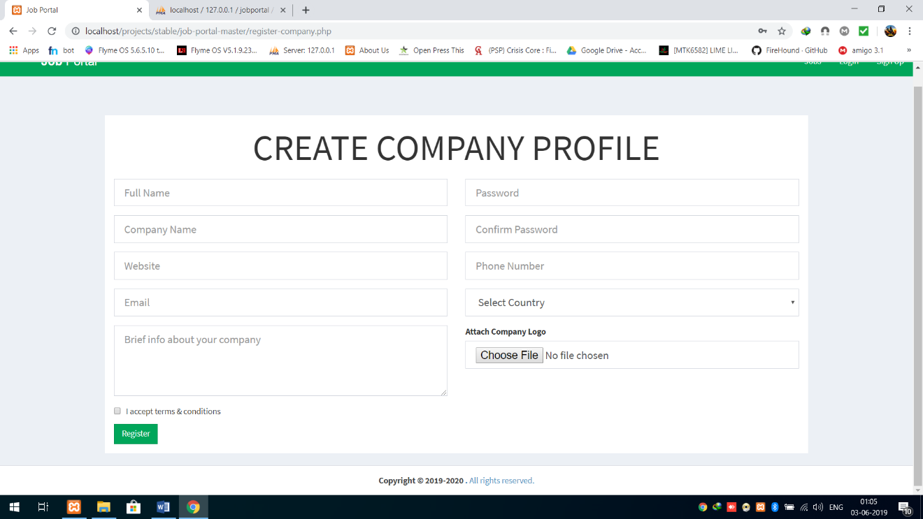

1. **User Section**

Profile

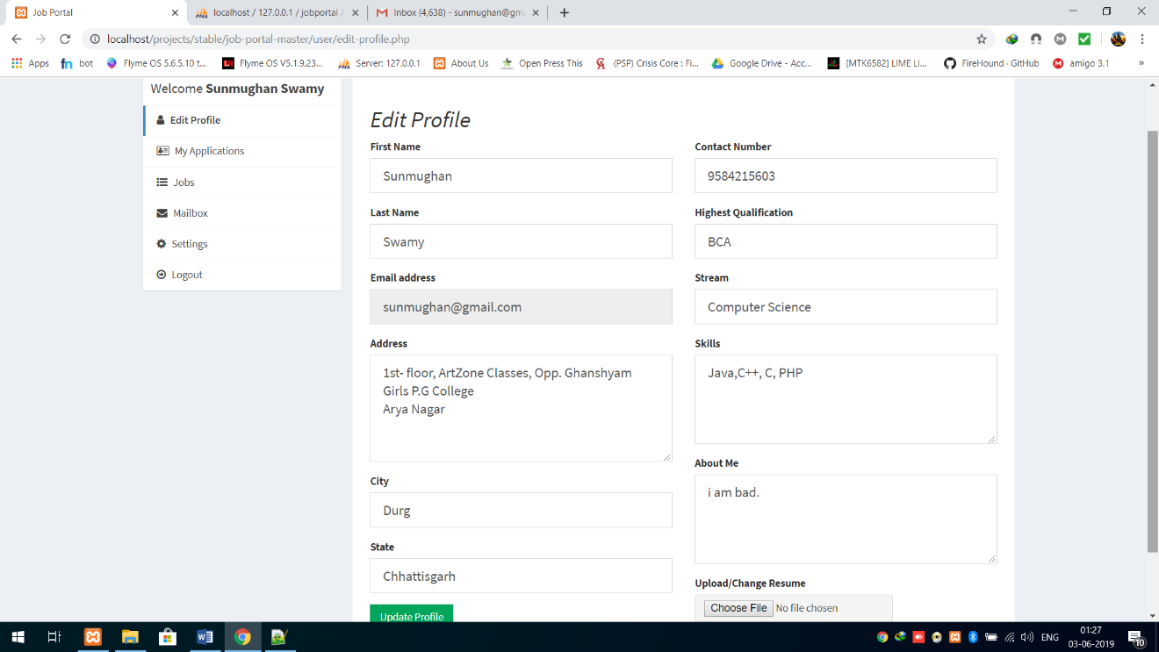

Application

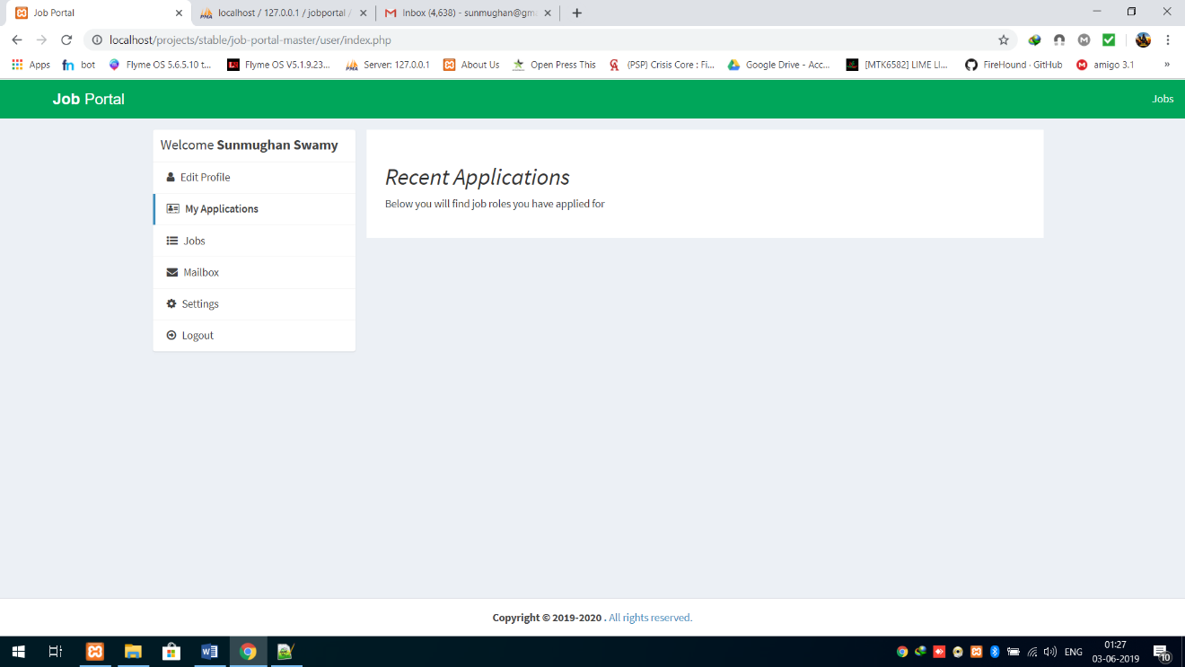

Jobs

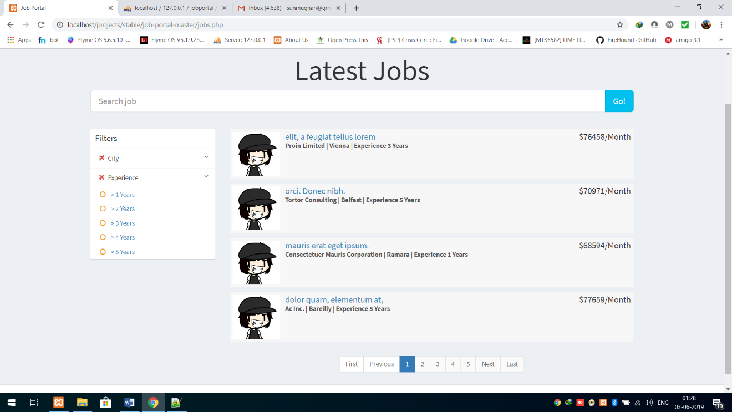

Mailbox

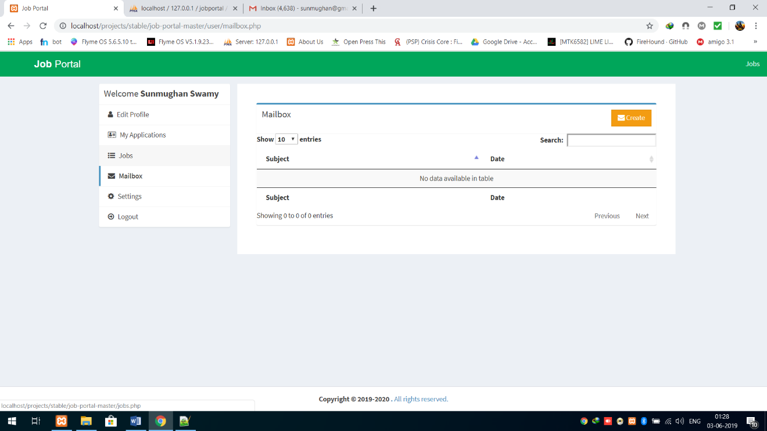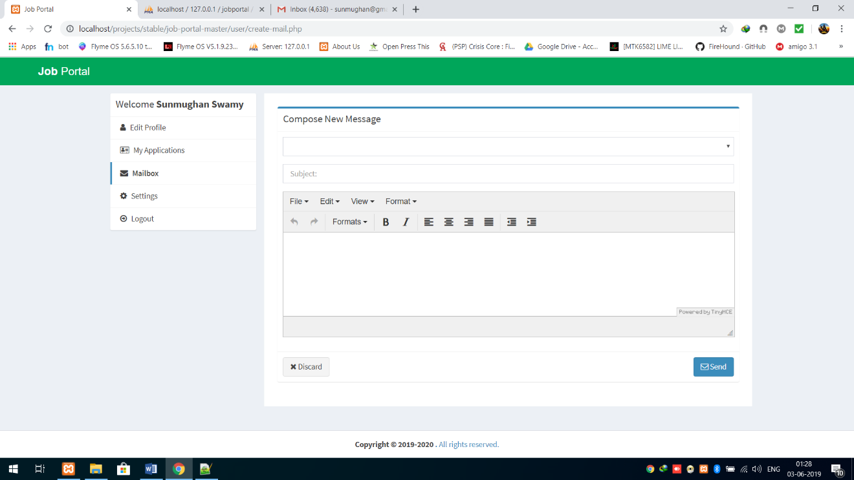

Settings

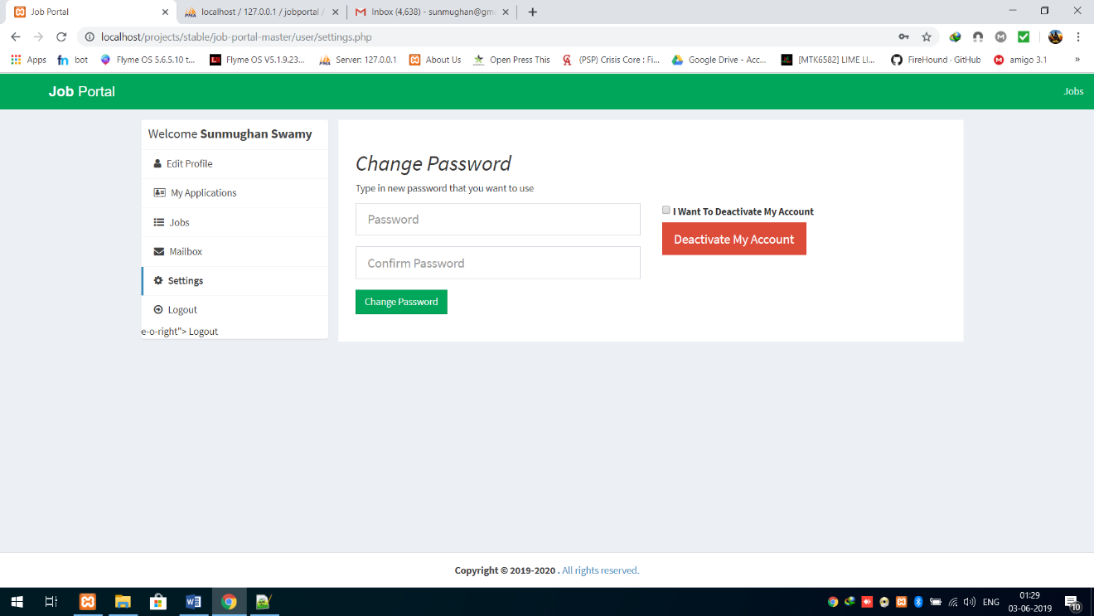

1. **Company Section**

Dashboard

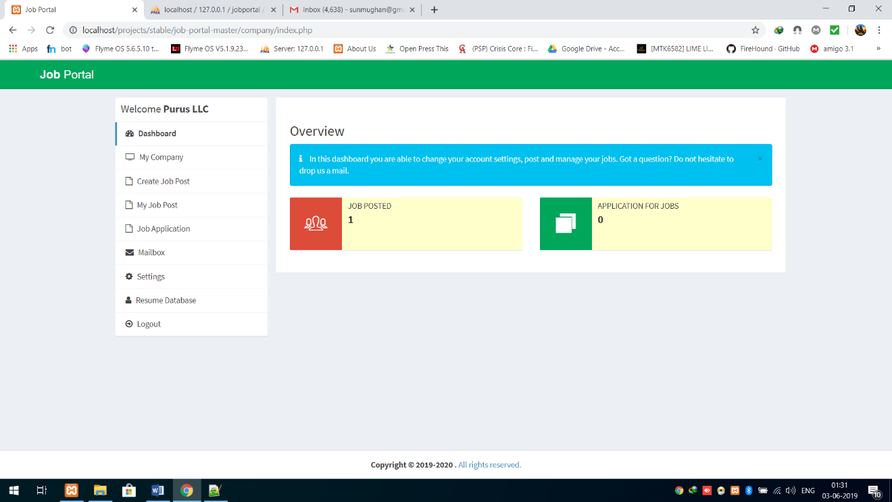

My Company

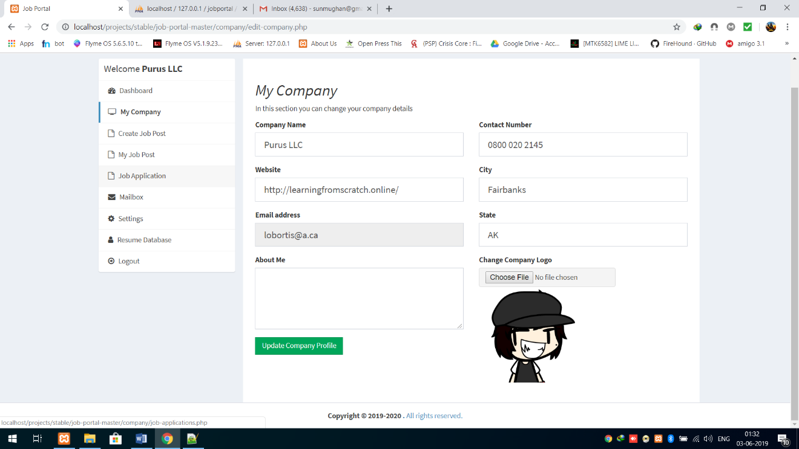

Create Job

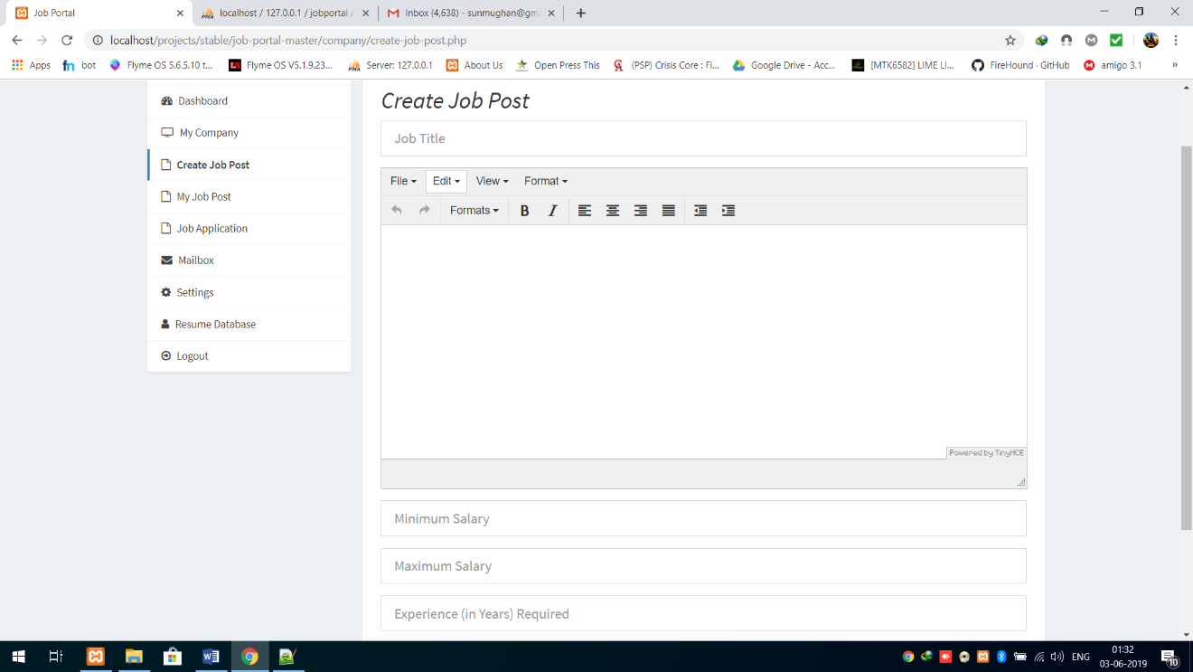

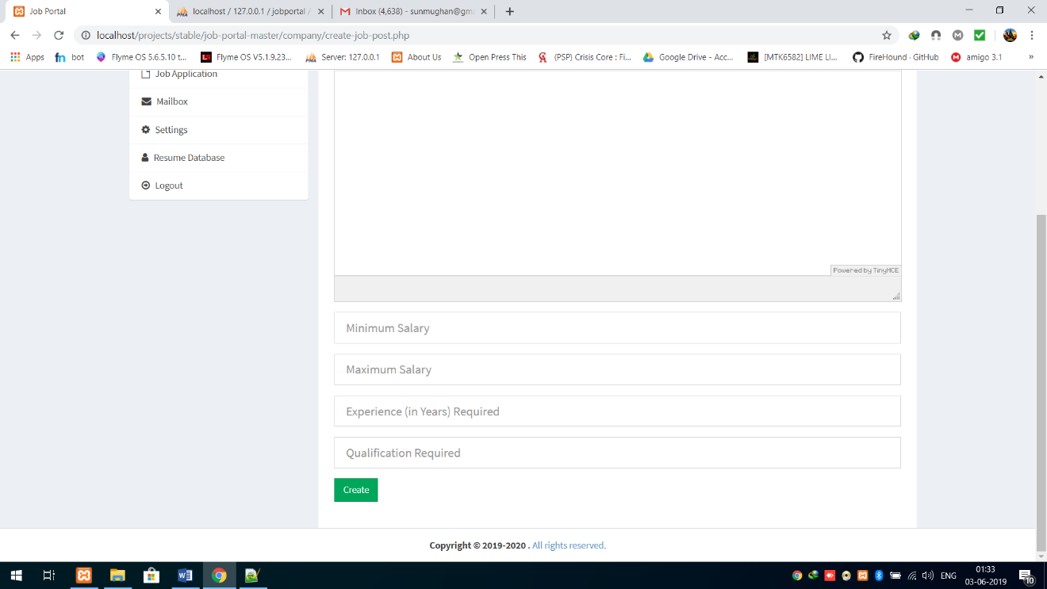

My Job Post

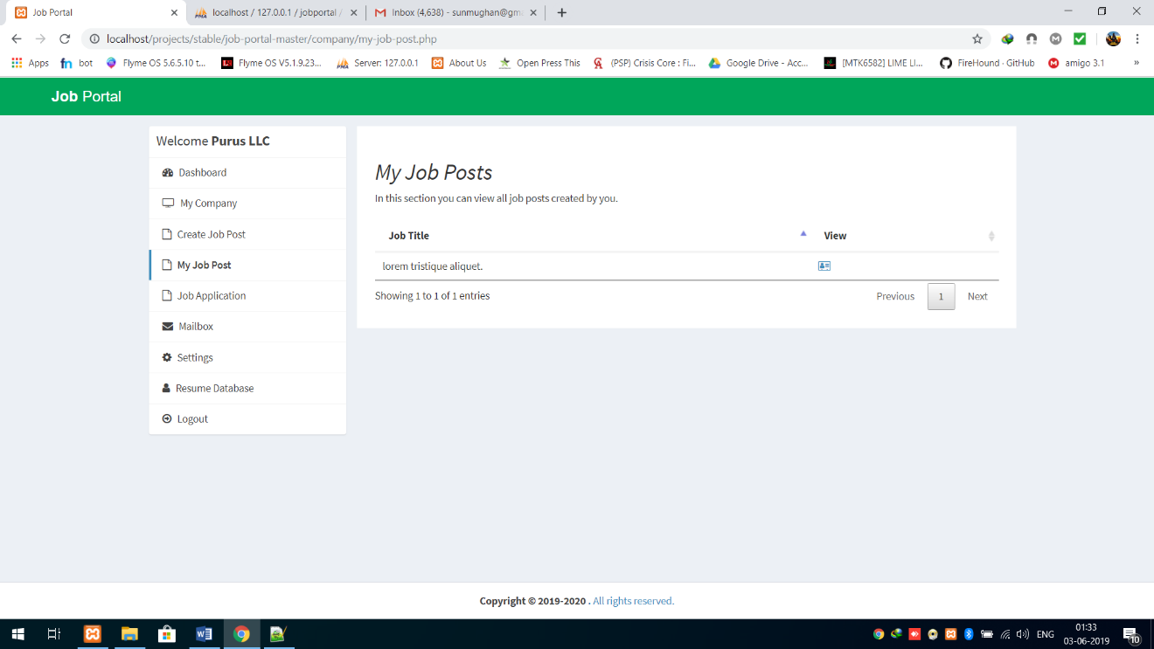

Job Application

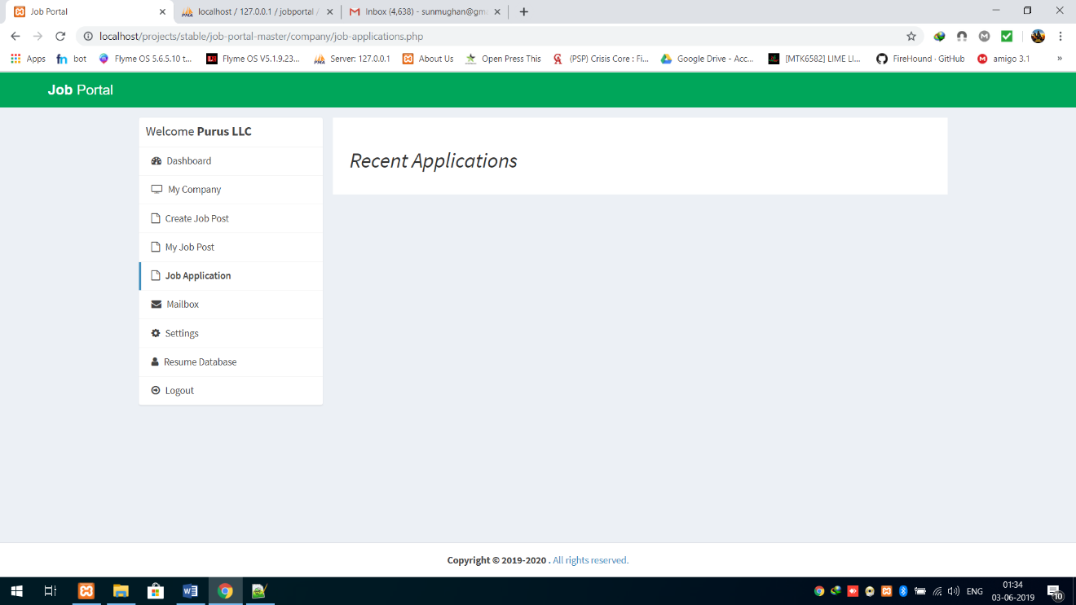

Mailbox

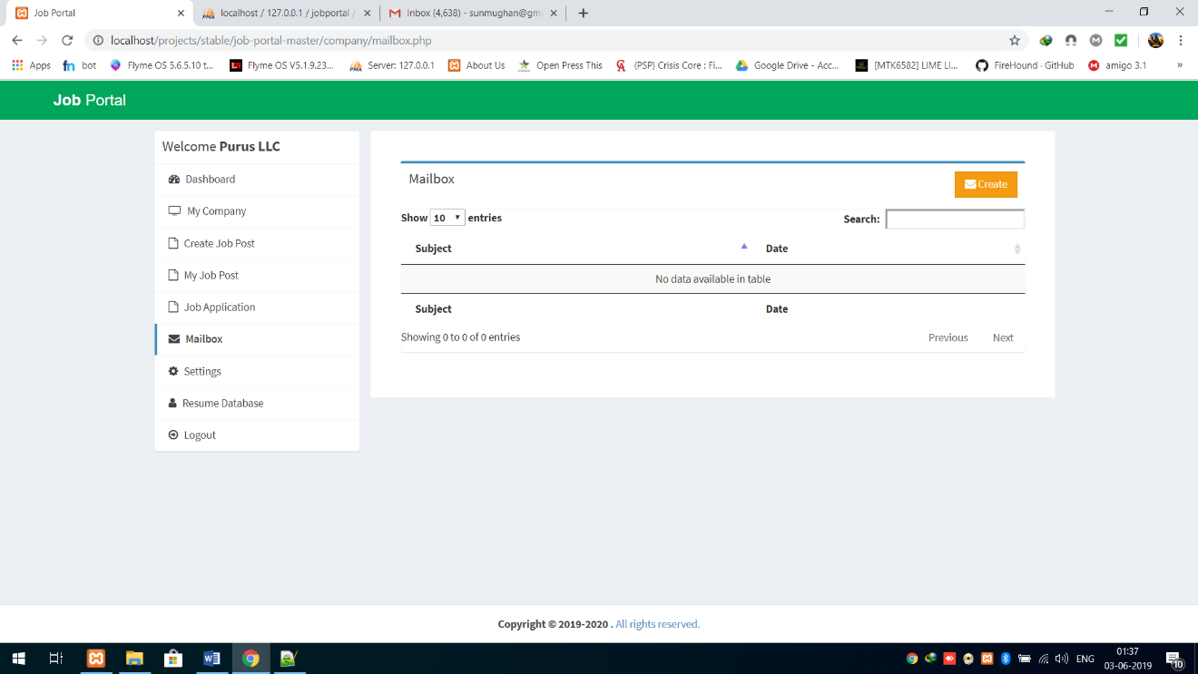

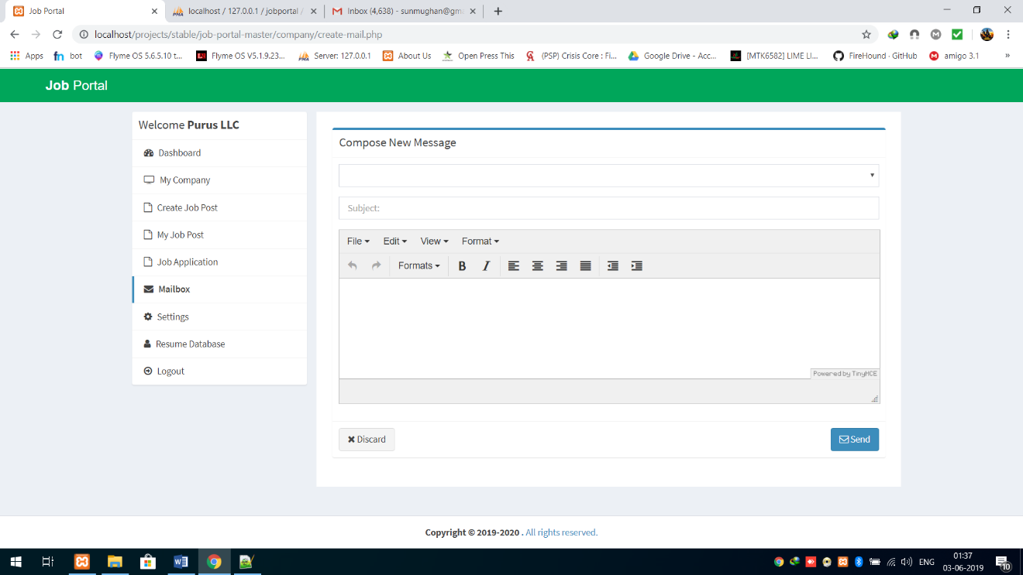

1. **Admin Section**

Admin Dashboard

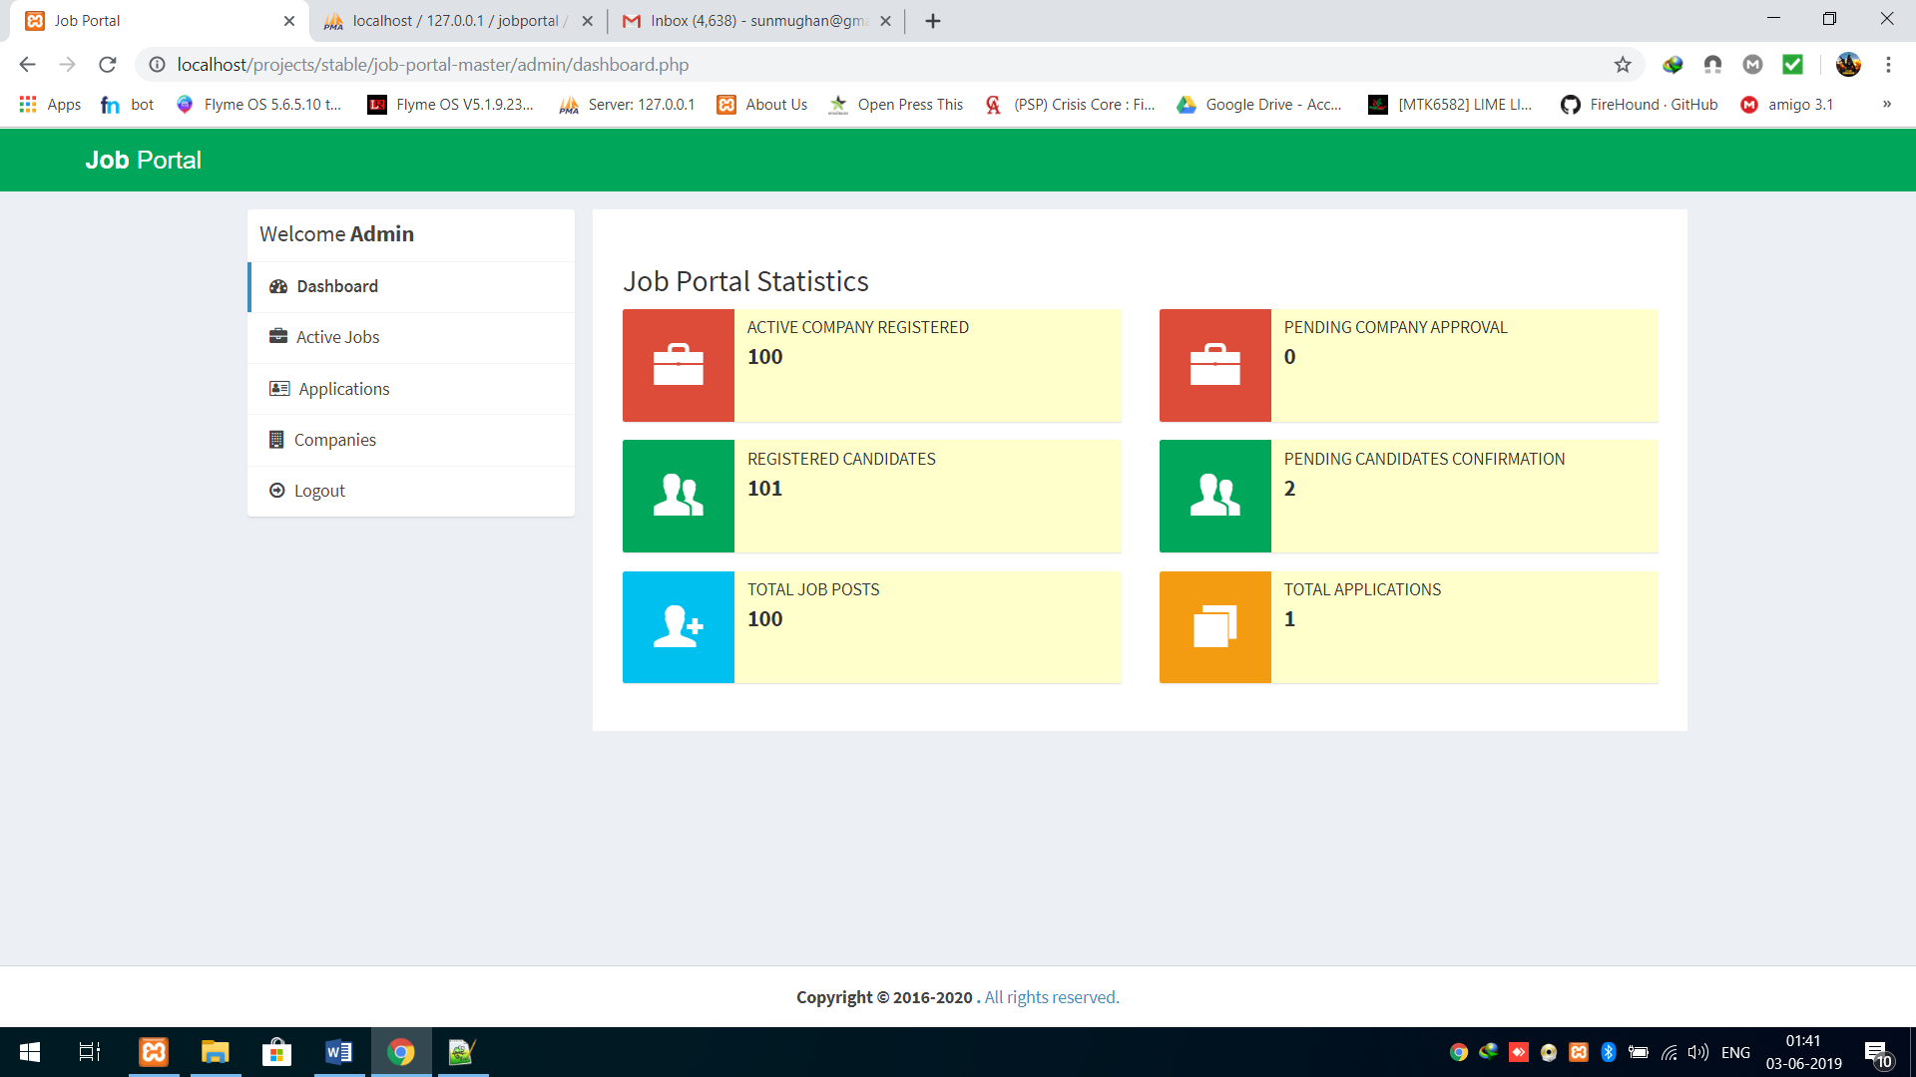

Active Jobs

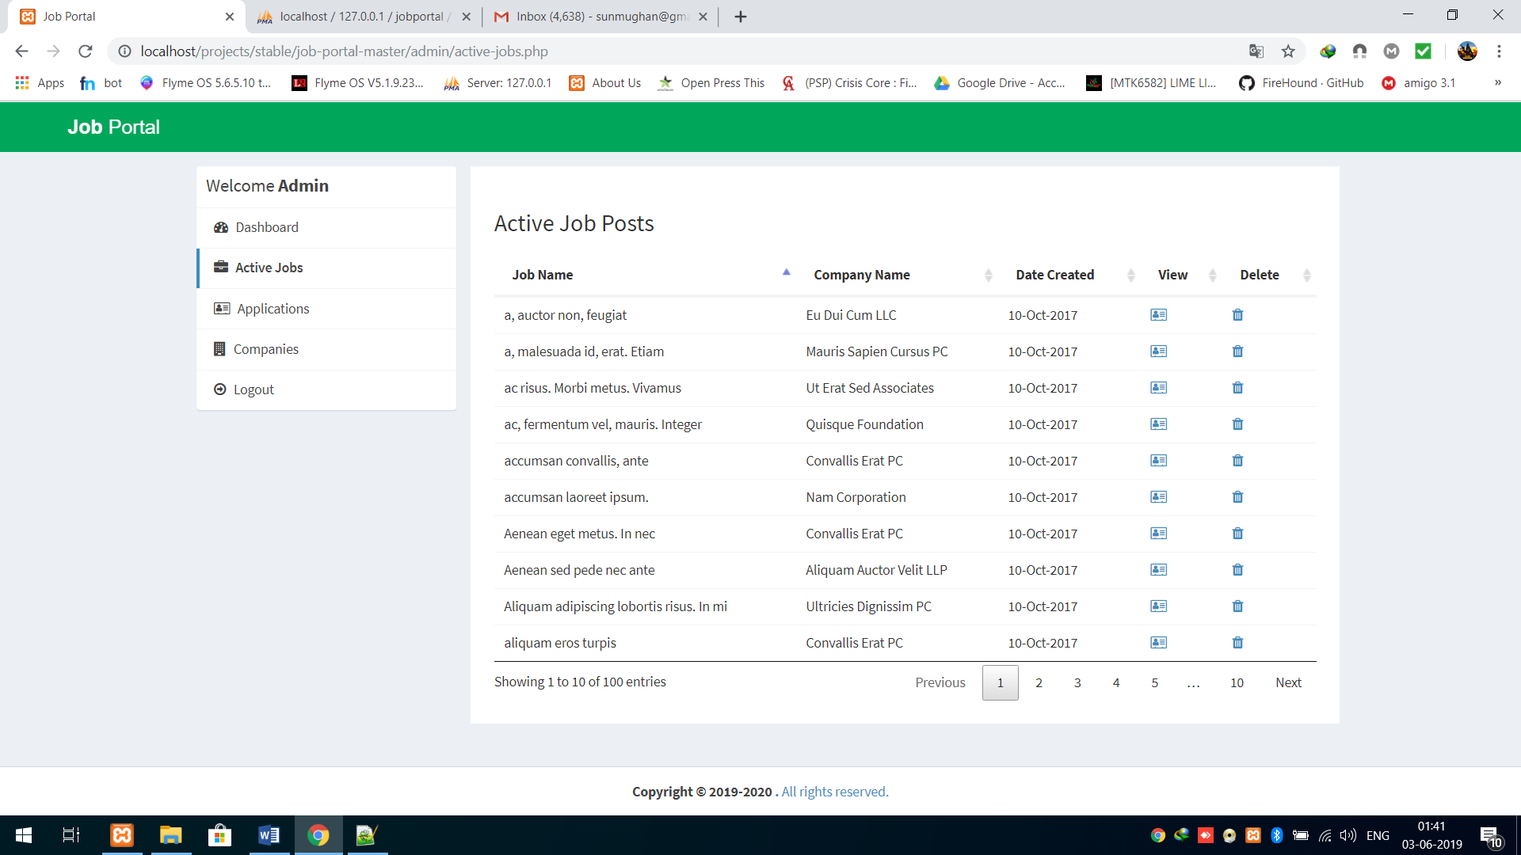

Candidates Database

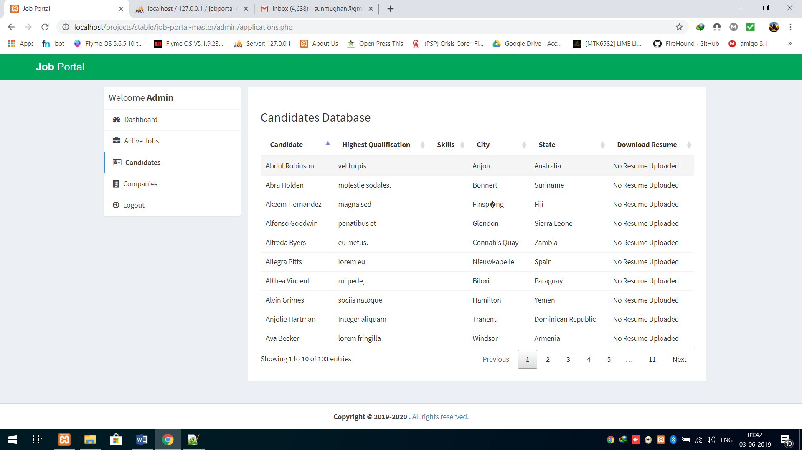

Companies

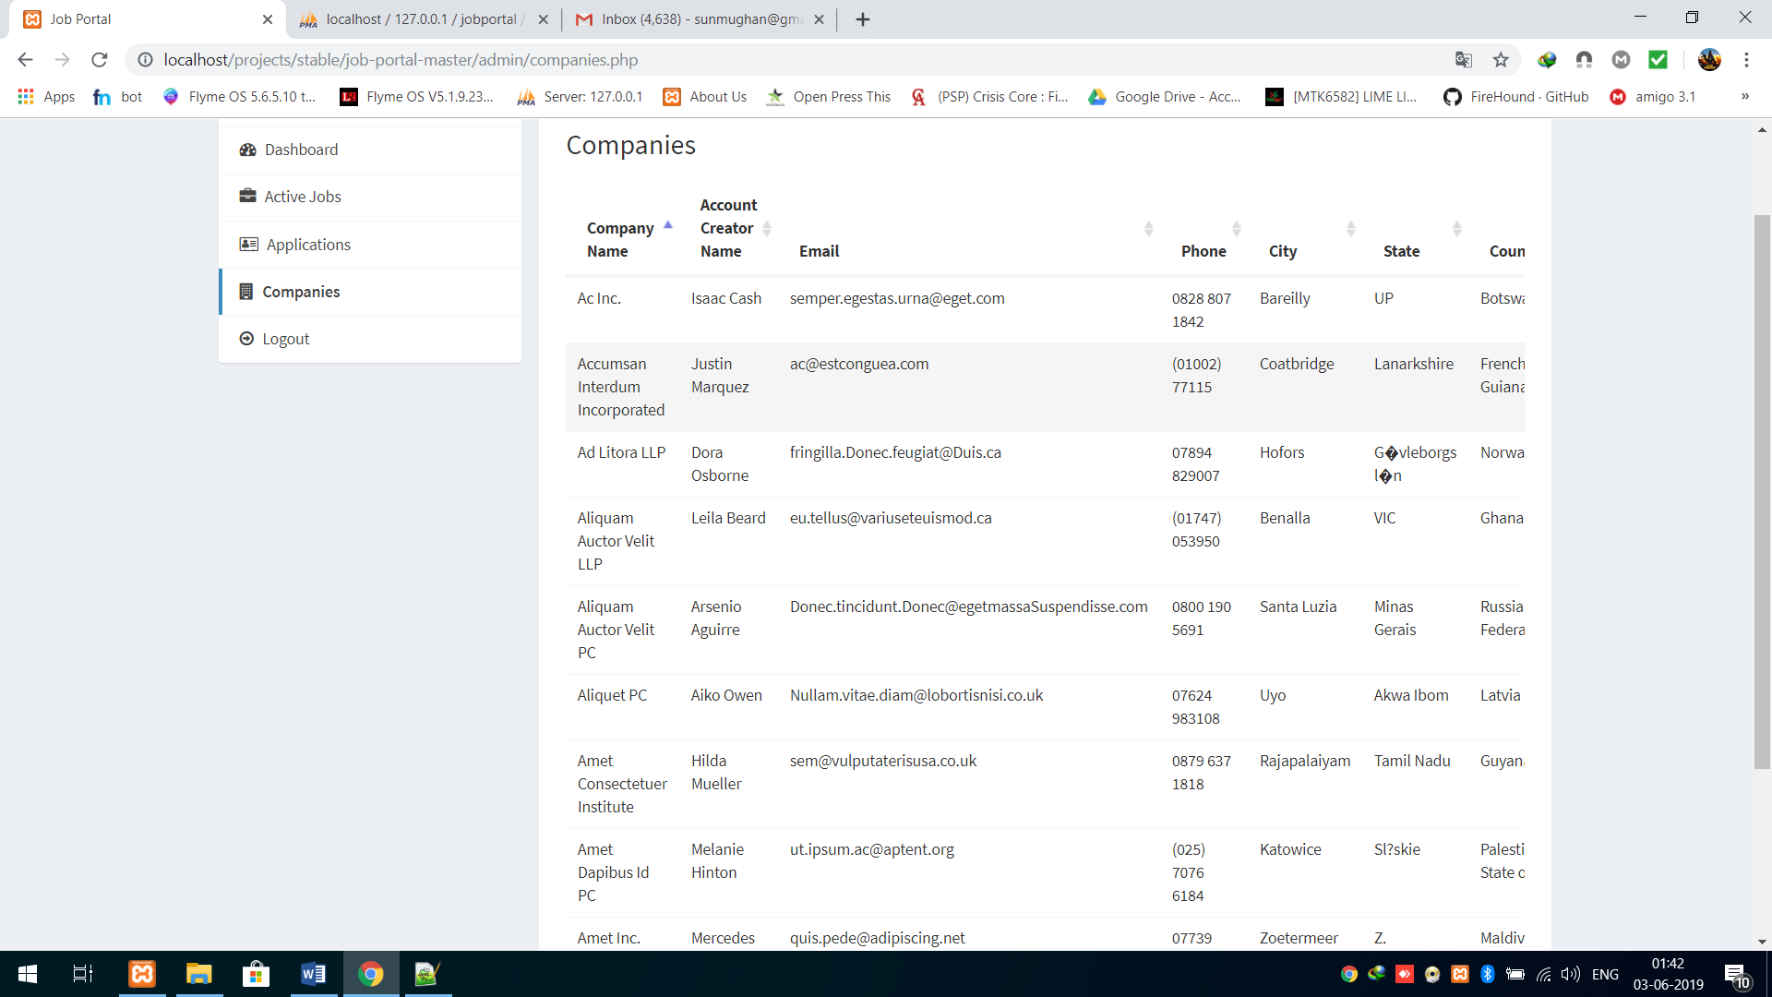

**___________________________**

**FORM CODING**

**___________________________**

**FORM CODINGS**

1. **Index.php**

<?php

//To Handle Session Variables on This Page

session_start();

//Including Database Connection From db.php file to avoid rewriting in all files

require_once("db.php");

?>

<!DOCTYPE html>

<html>

<head>

<meta charset="utf-8">

<meta http-equiv="X-UA-Compatible" content="IE=edge">

<title>Job Portal</title>

<!-- Tell the browser to be responsive to screen width -->

<meta content="width=device-width, initial-scale=1, maximum-scale=1, user-scalable=no" name="viewport">

<!-- Bootstrap 3.3.7 -->

<link rel="stylesheet" href="https://cdnjs.cloudflare.com/ajax/libs/twitter-bootstrap/3.3.7/css/bootstrap.min.css">

<!-- Font Awesome -->

<link rel="stylesheet" href="https://cdnjs.cloudflare.com/ajax/libs/font-awesome/4.7.0/css/font-awesome.min.css">

<!-- Ionicons -->

<link rel="stylesheet" href="https://cdnjs.cloudflare.com/ajax/libs/ionicons/2.0.1/css/ionicons.min.css">

<!-- Theme style -->

<link rel="stylesheet" href="css/AdminLTE.min.css">

<link rel="stylesheet" href="css/_all-skins.min.css">

<!-- Custom -->

<link rel="stylesheet" href="css/custom.css">

<!-- HTML5 Shim and Respond.js IE8 support of HTML5 elements and media queries -->

<!-- WARNING: Respond.js doesn't work if you view the page via file:// -->

<!--[if lt IE 9]>

<script src="https://oss.maxcdn.com/html5shiv/3.7.3/html5shiv.min.js"></script>

<script src="https://oss.maxcdn.com/respond/1.4.2/respond.min.js"></script>

<![endif]-->

<!-- Google Font -->

<link rel="stylesheet"

href="https://fonts.googleapis.com/css?family=Source+Sans+Pro:300,400,600,700,300italic,400italic,600italic">

</head>

<body class="hold-transition skin-green sidebar-mini">

<div class="wrapper">

<header class="main-header">

<!-- Logo -->

<a href="index.php" class="logo logo-bg">

<!-- mini logo for sidebar mini 50x50 pixels -->

<span class="logo-mini"><b>J</b>P</span>

<!-- logo for regular state and mobile devices -->

<span class="logo-lg"><b>Job</b> Portal</span>

</a>

<!-- Header Navbar: style can be found in header.less -->

<nav class="navbar navbar-static-top">

<!-- Navbar Right Menu -->

<div class="navbar-custom-menu">

<ul class="nav navbar-nav">

<li>

<a href="jobs.php">Jobs</a>

</li>

<li>

<a href="#candidates">Candidates</a>

</li>

<li>

<a href="#company">Company</a>

</li>

<li>

<a href="#about">About Us</a>

</li>

<?php if(empty($_SESSION['id_user']) && empty($_SESSION['id_company'])) { ?>

<li>

<a href="login.php">Login</a>

</li>

<li>

<a href="sign-up.php">Sign Up</a>

</li>

<?php } else {

if(isset($_SESSION['id_user'])) {

?>

<li>

<a href="user/index.php">Dashboard</a>

</li>

<?php

} else if(isset($_SESSION['id_company'])) {

?>

<li>

<a href="company/index.php">Dashboard</a>

</li>

<?php } ?>

<li>

<a href="logout.php">Logout</a>

</li>

<?php } ?>

</ul>

</div>

</nav>

</header>

<!-- Content Wrapper. Contains page content -->

<div class="content-wrapper" style="margin-left: 0px;">

<section class="content-header bg-main">

<div class="container">

<div class="row">

<div class="col-md-12 text-center index-head">

<h1>All <strong>JOBS</strong> In One Place</h1>

<p>One search, global reach</p>

<p><a class="btn btn-success btn-lg" href="jobs.php" role="button">Search Jobs</a></p>

</div>

</div>

</div>

</section>

<section class="content-header">

<div class="container">

<div class="row">

<div class="col-md-12 latest-job margin-bottom-20">

<h1 class="text-center">Latest Jobs</h1>

<?php

/* Show any 4 random job post

*

* Store sql query result in $result variable and loop through it if we have any rows

* returned from database. $result->num_rows will return total number of rows returned from database.

*/

$sql = "SELECT * FROM job_post Order By Rand() Limit 4";

$result = $conn->query($sql);

if($result->num_rows > 0) {

while($row = $result->fetch_assoc())

{

$sql1 = "SELECT * FROM company WHERE id_company='$row[id_company]'";

$result1 = $conn->query($sql1);

if($result1->num_rows > 0) {

while($row1 = $result1->fetch_assoc())

{

?>

<div class="attachment-block clearfix">

<img class="attachment-img" src="img/photo1.png" alt="Attachment Image">

<div class="attachment-pushed">

<h4 class="attachment-heading"><a href="view-job-post.php?id=<?php echo $row['id_jobpost']; ?>"><?php echo $row['jobtitle']; ?></a> <span class="attachment-heading pull-right">$<?php echo $row['maximumsalary']; ?>/Month</span></h4>

<div class="attachment-text">

<div><strong><?php echo $row1['companyname']; ?> | <?php echo $row1['city']; ?> | Experience <?php echo $row['experience']; ?> Years</strong></div>

</div>

</div>

</div>

<?php

}

}

}

}

?>

</div>

</div>

</div>

</section>

<section id="candidates" class="content-header">

<div class="container">

<div class="row">

<div class="col-md-12 text-center latest-job margin-bottom-20">

<h1>Candidates</h1>

<p>Finding a job just got easier. Create a profile and apply with single mouse click.</p>

</div>

</div>

<div class="row">

<div class="col-sm-4 col-md-4">

<div class="thumbnail candidate-img">

<img src="img/browse.jpg" alt="Browse Jobs">

<div class="caption">

<h3 class="text-center">Browse Jobs</h3>

</div>

</div>

</div>

<div class="col-sm-4 col-md-4">

<div class="thumbnail candidate-img">

<img src="img/interviewed.jpeg" alt="Apply & Get Interviewed">

<div class="caption">

<h3 class="text-center">Apply & Get Interviewed</h3>

</div>

</div>

</div>

<div class="col-sm-4 col-md-4">

<div class="thumbnail candidate-img">

<img src="img/career.jpg" alt="Start A Career">

<div class="caption">

<h3 class="text-center">Start A Career</h3>

</div>

</div>

</div>

</div>

</div>

</section>

<section id="company" class="content-header">

<div class="container">

<div class="row">

<div class="col-md-12 text-center latest-job margin-bottom-20">

<h1>Companies</h1>

<p>Hiring? Register your company for free, browse our talented pool, post and track job applications</p>

</div>

</div>

<div class="row">

<div class="col-sm-4 col-md-4">

<div class="thumbnail company-img">

<img src="img/postjob.png" alt="Browse Jobs">

<div class="caption">

<h3 class="text-center">Post A Job</h3>

</div>

</div>

</div>

<div class="col-sm-4 col-md-4">

<div class="thumbnail company-img">

<img src="img/manage.jpg" alt="Apply & Get Interviewed">

<div class="caption">

<h3 class="text-center">Manage & Track</h3>

</div>

</div>

</div>

<div class="col-sm-4 col-md-4">

<div class="thumbnail company-img">

<img src="img/hire.png" alt="Start A Career">

<div class="caption">

<h3 class="text-center">Hire</h3>

</div>

</div>

</div>

</div>

</div>

</section>

<section id="statistics" class="content-header">

<div class="container">

<div class="row">

<div class="col-md-12 text-center latest-job margin-bottom-20">

<h1>Our Statistics</h1>

</div>

</div>

<div class="row">

<div class="col-lg-3 col-xs-6">

<!-- small box -->

<div class="small-box bg-aqua">

<div class="inner">

<?php

$sql = "SELECT * FROM job_post";

$result = $conn->query($sql);

if($result->num_rows > 0) {

$totalno = $result->num_rows;

} else {

$totalno = 0;

}

?>

<h3><?php echo $totalno; ?></h3>

<p>Job Offers</p>

</div>

<div class="icon">

<i class="ion ion-ios-paper"></i>

</div>

</div>

</div>

<!-- ./col -->

<div class="col-lg-3 col-xs-6">

<!-- small box -->

<div class="small-box bg-green">

<div class="inner">

<?php

$sql = "SELECT * FROM company WHERE active='1'";

$result = $conn->query($sql);

if($result->num_rows > 0) {

$totalno = $result->num_rows;

} else {

$totalno = 0;

}

?>

<h3><?php echo $totalno; ?></h3>

<p>Registered Company</p>

</div>

<div class="icon">

<i class="ion ion-briefcase"></i>

</div>

</div>

</div>

<!-- ./col -->

<div class="col-lg-3 col-xs-6">

<!-- small box -->

<div class="small-box bg-yellow">

<div class="inner">

<?php

$sql = "SELECT * FROM users WHERE resume!=''";

$result = $conn->query($sql);

if($result->num_rows > 0) {

$totalno = $result->num_rows;

} else {

$totalno = 0;

}

?>

<h3><?php echo $totalno; ?></h3>

<p>CV'S/Resume</p>

</div>

<div class="icon">

<i class="ion ion-ios-list"></i>

</div>

</div>

</div>

<!-- ./col -->

<div class="col-lg-3 col-xs-6">

<!-- small box -->

<div class="small-box bg-red">

<div class="inner">

<?php

$sql = "SELECT * FROM users WHERE active='1'";

$result = $conn->query($sql);

if($result->num_rows > 0) {

$totalno = $result->num_rows;

} else {

$totalno = 0;

}

?>

<h3><?php echo $totalno; ?></h3>

<p>Daily Users</p>

</div>

<div class="icon">

<i class="ion ion-person-stalker"></i>

</div>

</div>

</div>

<!-- ./col -->

</div>

</div>

</section>

<section id="about" class="content-header">

<div class="container">

<div class="row">

<div class="col-md-12 text-center latest-job margin-bottom-20">

<h1>About US</h1>

</div>

</div>

<div class="row">

<div class="col-md-6">

<img src="img/browse.jpg" class="img-responsive">

</div>

<div class="col-md-6 about-text margin-bottom-20">

<p>Lorem ipsum dolor sit amet, consectetur adipisicing <p>The online job portal application allows job seekers and recruiters to connect.The application provides the ability for job seekers to create their accounts, upload their profile and resume, search for jobs, apply for jobs, view different job openings. The application provides the ability for companies to create their accounts, search candidates, create job postings, and view candidates applications.

</p>

<p>

This website is used to provide a platform for potential candidates to get their dream job and excel in yheir career.

This site can be used as a paving path for both companies and job-seekers for a better life .

</p>

</div>

</div>

</div>

</section>

</div>

<!-- /.content-wrapper -->

<footer class="main-footer" style="margin-left: 0px;">

<div class="text-center">

<strong>Copyright &copy; 2019-2020 <a href="http://titanx.in">Titanx Ocean</a>.</strong> All rights reserved.

</div>

</footer>

<!-- /.control-sidebar -->

<!-- Add the sidebar's background. This div must be placed

immediately after the control sidebar -->

<div class="control-sidebar-bg"></div>

</div>

<!-- ./wrapper -->

<!-- jQuery 3 -->

<script src="https://cdnjs.cloudflare.com/ajax/libs/jquery/3.2.1/jquery.min.js"></script>

<!-- Bootstrap 3.3.7 -->

<script src="https://cdnjs.cloudflare.com/ajax/libs/twitter-bootstrap/3.3.7/js/bootstrap.min.js"></script>

<!-- AdminLTE App -->

<script src="js/adminlte.min.js"></script>

</body>

</html>

1. **Login.php**

<?php

session_start();

if(isset($_SESSION['id_user']) || isset($_SESSION['id_company'])) {

header("Location: index.php");

exit();

}

?>

<!DOCTYPE html>

<html>

<head>

<meta charset="utf-8">

<meta http-equiv="X-UA-Compatible" content="IE=edge">

<title>Job Portal</title>

<!-- Tell the browser to be responsive to screen width -->

<meta content="width=device-width, initial-scale=1, maximum-scale=1, user-scalable=no" name="viewport">

<!-- Bootstrap 3.3.7 -->

<link rel="stylesheet" href="https://cdnjs.cloudflare.com/ajax/libs/twitter-bootstrap/3.3.7/css/bootstrap.min.css">

<!-- Font Awesome -->

<link rel="stylesheet" href="https://cdnjs.cloudflare.com/ajax/libs/font-awesome/4.7.0/css/font-awesome.min.css">

<!-- Ionicons -->

<link rel="stylesheet" href="https://cdnjs.cloudflare.com/ajax/libs/ionicons/2.0.1/css/ionicons.min.css">

<!-- Theme style -->

<link rel="stylesheet" href="css/AdminLTE.min.css">

<link rel="stylesheet" href="css/_all-skins.min.css">

<!-- Custom -->

<link rel="stylesheet" href="css/custom.css">

<!-- HTML5 Shim and Respond.js IE8 support of HTML5 elements and media queries -->

<!-- WARNING: Respond.js doesn't work if you view the page via file:// -->

<!--[if lt IE 9]>

<script src="https://oss.maxcdn.com/html5shiv/3.7.3/html5shiv.min.js"></script>

<script src="https://oss.maxcdn.com/respond/1.4.2/respond.min.js"></script>

<![endif]-->

<!-- Google Font -->

<link rel="stylesheet"

href="https://fonts.googleapis.com/css?family=Source+Sans+Pro:300,400,600,700,300italic,400italic,600italic">

</head>

<body class="hold-transition skin-green sidebar-mini">

<div class="wrapper">

<header class="main-header">

<!-- Logo -->

<a href="index.php" class="logo logo-bg">

<!-- mini logo for sidebar mini 50x50 pixels -->

<span class="logo-mini"><b>J</b>P</span>

<!-- logo for regular state and mobile devices -->

<span class="logo-lg"><b>Job</b> Portal</span>

</a>

<!-- Header Navbar: style can be found in header.less -->

<nav class="navbar navbar-static-top">

<!-- Navbar Right Menu -->

<div class="navbar-custom-menu">

<ul class="nav navbar-nav">

<li>

<a href="jobs.php">Jobs</a>

</li>

<?php if(empty($_SESSION['id_user']) && empty($_SESSION['id_company'])) { ?>

<li>

<a href="login.php">Login</a>

</li>

<li>

<a href="sign-up.php">Sign Up</a>

</li>

<?php } else {

if(isset($_SESSION['id_user'])) {

?>

<li>

<a href="user/index.php">Dashboard</a>

</li>

<?php

} else if(isset($_SESSION['id_company'])) {

?>

<li>

<a href="company/index.php">Dashboard</a>

</li>

<?php } ?>

<li>

<a href="logout.php">Logout</a>

</li>

<?php } ?>

</ul>

</div>

</nav>

</header>

<!-- Content Wrapper. Contains page content -->

<div class="content-wrapper" style="margin-left: 0px;">

<section class="content-header">

<div class="container">

<div class="row latest-job margin-top-50 margin-bottom-20">

<h1 class="text-center margin-bottom-20">Sign Up</h1>

<div class="col-md-6 latest-job ">

<div class="small-box bg-yellow padding-5">

<div class="inner">

<h3 class="text-center">Candidates Login</h3>

</div>

<a href="login-candidates.php" class="small-box-footer">

Login <i class="fa fa-arrow-circle-right"></i>

</a>

</div>

</div>

<div class="col-md-6 latest-job ">

<div class="small-box bg-red padding-5">

<div class="inner">

<h3 class="text-center">Company Login</h3>

</div>

<a href="login-company.php" class="small-box-footer">

Login <i class="fa fa-arrow-circle-right"></i>

</a>

</div>

</div>

</div>

</div>

</section>

</div>

<!-- /.content-wrapper -->

<footer class="main-footer" style="margin-left: 0px;">

<div class="text-center">

<strong>Copyright &copy; 2019-2020 <a href="http://titanx.in"Titanx Ocean</a>.</strong> All rights reserved.

</div>

</footer>

<!-- /.control-sidebar -->

<!-- Add the sidebar's background. This div must be placed

immediately after the control sidebar -->

<div class="control-sidebar-bg"></div>

</div>

<!-- ./wrapper -->

<!-- jQuery 3 -->

<script src="https://cdnjs.cloudflare.com/ajax/libs/jquery/3.2.1/jquery.min.js"></script>

<!-- Bootstrap 3.3.7 -->

<script src="https://cdnjs.cloudflare.com/ajax/libs/twitter-bootstrap/3.3.7/js/bootstrap.min.js"></script>

<!-- AdminLTE App -->

<script src="js/adminlte.min.js"></script>

</body>

</html>

1. **Signup.php**

<?php

session_start();

if(isset($_SESSION['id_user']) || isset($_SESSION['id_company'])) {

header("Location: index.php");

exit();

}

?>

<!DOCTYPE html>

<html>

<head>

<meta charset="utf-8">

<meta http-equiv="X-UA-Compatible" content="IE=edge">

<title>Job Portal</title>

<!-- Tell the browser to be responsive to screen width -->

<meta content="width=device-width, initial-scale=1, maximum-scale=1, user-scalable=no" name="viewport">

<!-- Bootstrap 3.3.7 -->

<link rel="stylesheet" href="https://cdnjs.cloudflare.com/ajax/libs/twitter-bootstrap/3.3.7/css/bootstrap.min.css">

<!-- Font Awesome -->

<link rel="stylesheet" href="https://cdnjs.cloudflare.com/ajax/libs/font-awesome/4.7.0/css/font-awesome.min.css">

<!-- Ionicons -->

<link rel="stylesheet" href="https://cdnjs.cloudflare.com/ajax/libs/ionicons/2.0.1/css/ionicons.min.css">

<!-- Theme style -->

<link rel="stylesheet" href="css/AdminLTE.min.css">

<link rel="stylesheet" href="css/_all-skins.min.css">

<!-- Custom -->

<link rel="stylesheet" href="css/custom.css">

<!-- HTML5 Shim and Respond.js IE8 support of HTML5 elements and media queries -->

<!-- WARNING: Respond.js doesn't work if you view the page via file:// -->

<!--[if lt IE 9]>

<script src="https://oss.maxcdn.com/html5shiv/3.7.3/html5shiv.min.js"></script>

<script src="https://oss.maxcdn.com/respond/1.4.2/respond.min.js"></script>

<![endif]-->

<!-- Google Font -->

<link rel="stylesheet"

href="https://fonts.googleapis.com/css?family=Source+Sans+Pro:300,400,600,700,300italic,400italic,600italic">

</head>

<body class="hold-transition skin-green sidebar-mini">

<div class="wrapper">

<header class="main-header">

<!-- Logo -->

<a href="index.php" class="logo logo-bg">

<!-- mini logo for sidebar mini 50x50 pixels -->

<span class="logo-mini"><b>J</b>P</span>

<!-- logo for regular state and mobile devices -->

<span class="logo-lg"><b>Job</b> Portal</span>

</a>

<!-- Header Navbar: style can be found in header.less -->

<nav class="navbar navbar-static-top">

<!-- Navbar Right Menu -->

<div class="navbar-custom-menu">

<ul class="nav navbar-nav">

<li>

<a href="jobs.php">Jobs</a>

</li>

<?php if(empty($_SESSION['id_user']) && empty($_SESSION['id_company'])) { ?>

<li>

<a href="login.php">Login</a>

</li>

<li>

<a href="sign-up.php">Sign Up</a>

</li>

<?php } else {

if(isset($_SESSION['id_user'])) {

?>

<li>

<a href="user/index.php">Dashboard</a>

</li>

<?php

} else if(isset($_SESSION['id_company'])) {

?>

<li>

<a href="company/index.php">Dashboard</a>

</li>

<?php } ?>

<li>

<a href="logout.php">Logout</a>

</li>

<?php } ?>

</ul>

</div>

</nav>

</header>

<!-- Content Wrapper. Contains page content -->

<div class="content-wrapper" style="margin-left: 0px;">

<section class="content-header">

<div class="container">

<div class="row latest-job margin-top-50 margin-bottom-20">

<h1 class="text-center margin-bottom-20">Sign Up</h1>

<div class="col-md-6 latest-job ">

<div class="small-box bg-yellow padding-5">

<div class="inner">

<h3 class="text-center">User Registration</h3>

</div>

<a href="register-candidates.php" class="small-box-footer">

Register <i class="fa fa-arrow-circle-right"></i>

</a>

</div>

</div>

<div class="col-md-6 latest-job ">

<div class="small-box bg-red padding-5">

<div class="inner">

<h3 class="text-center">Company Registration</h3>

</div>

<a href="register-company.php" class="small-box-footer">

Register <i class="fa fa-arrow-circle-right"></i>

</a>

</div>

</div>

</div>

</div>

</section>

</div>

<!-- /.content-wrapper -->

<footer class="main-footer" style="margin-left: 0px;">

<div class="text-center">

<strong>Copyright &copy; 2019-2020 <a href="http://titanx.in"Titanx Ocean</a>.</strong> All rights reserved.

</div>

</footer>

<!-- /.control-sidebar -->

<!-- Add the sidebar's background. This div must be placed

immediately after the control sidebar -->

<div class="control-sidebar-bg"></div>

</div>

<!-- ./wrapper -->

<!-- jQuery 3 -->

<script src="https://cdnjs.cloudflare.com/ajax/libs/jquery/3.2.1/jquery.min.js"></script>

<!-- Bootstrap 3.3.7 -->

<script src="https://cdnjs.cloudflare.com/ajax/libs/twitter-bootstrap/3.3.7/js/bootstrap.min.js"></script>

<!-- AdminLTE App -->

<script src="js/adminlte.min.js"></script>

</body>

</html>

1. **Jobs.php**

<?php

//To Handle Session Variables on This Page

session_start();

//Including Database Connection From db.php file to avoid rewriting in all files

require_once("db.php");

?>

<!DOCTYPE html>

<html>

<head>

<meta charset="utf-8">

<meta http-equiv="X-UA-Compatible" content="IE=edge">

<title>Job Portal</title>

<!-- Tell the browser to be responsive to screen width -->

<meta content="width=device-width, initial-scale=1, maximum-scale=1, user-scalable=no" name="viewport">

<!-- Bootstrap 3.3.7 -->

<link rel="stylesheet" href="https://cdnjs.cloudflare.com/ajax/libs/twitter-bootstrap/3.3.7/css/bootstrap.min.css">

<!-- Font Awesome -->

<link rel="stylesheet" href="https://cdnjs.cloudflare.com/ajax/libs/font-awesome/4.7.0/css/font-awesome.min.css">

<!-- Ionicons -->

<link rel="stylesheet" href="https://cdnjs.cloudflare.com/ajax/libs/ionicons/2.0.1/css/ionicons.min.css">

<!-- Theme style -->

<link rel="stylesheet" href="css/AdminLTE.min.css">

<link rel="stylesheet" href="css/_all-skins.min.css">

<!-- Custom -->

<link rel="stylesheet" href="css/custom.css">

<!-- HTML5 Shim and Respond.js IE8 support of HTML5 elements and media queries -->

<!-- WARNING: Respond.js doesn't work if you view the page via file:// -->

<!--[if lt IE 9]>

<script src="https://oss.maxcdn.com/html5shiv/3.7.3/html5shiv.min.js"></script>

<script src="https://oss.maxcdn.com/respond/1.4.2/respond.min.js"></script>

<![endif]-->

<!-- Google Font -->

<link rel="stylesheet"

href="https://fonts.googleapis.com/css?family=Source+Sans+Pro:300,400,600,700,300italic,400italic,600italic">

</head>

<body class="hold-transition skin-green sidebar-mini">

<div class="wrapper">

<header class="main-header">

<!-- Logo -->

<a href="index.php" class="logo logo-bg">

<!-- mini logo for sidebar mini 50x50 pixels -->

<span class="logo-mini"><b>J</b>P</span>

<!-- logo for regular state and mobile devices -->

<span class="logo-lg"><b>Job</b> Portal</span>

</a>

<!-- Header Navbar: style can be found in header.less -->

<nav class="navbar navbar-static-top">

<!-- Navbar Right Menu -->

<div class="navbar-custom-menu">

<ul class="nav navbar-nav">

<?php if(empty($_SESSION['id_user']) && empty($_SESSION['id_company'])) { ?>

<li>

<a href="login.php">Login</a>

</li>

<li>

<a href="sign-up.php">Sign Up</a>

</li>

<?php } else {

if(isset($_SESSION['id_user'])) {

?>

<li>

<a href="user/index.php">Dashboard</a>

</li>

<?php

} else if(isset($_SESSION['id_company'])) {

?>

<li>

<a href="company/index.php">Dashboard</a>

</li>

<?php } ?>

<li>

<a href="logout.php">Logout</a>

</li>

<?php } ?>

</ul>

</div>

</nav>

</header>

<!-- Content Wrapper. Contains page content -->

<div class="content-wrapper" style="margin-left: 0px;">

<section class="content-header">

<div class="container">

<div class="row">

<div class="col-md-12 latest-job margin-top-50 margin-bottom-20">

<h1 class="text-center">Latest Jobs</h1>

<div class="input-group input-group-lg">

<input type="text" id="searchBar" class="form-control" placeholder="Search job">

<span class="input-group-btn">

<button id="searchBtn" type="button" class="btn btn-info btn-flat">Go!</button>

</span>

</div>

</div>

</div>

</div>

</section>

<section id="candidates" class="content-header">

<div class="container">

<div class="row">

<div class="col-md-3">

<div class="box box-solid">

<div class="box-header with-border">

<h3 class="box-title">Filters</h3>

</div>

<div class="box-body no-padding">

<ul class="nav nav-pills nav-stacked tree" data-widget="tree">

<li class="treeview menu-open">

<a href="#"><i class="fa fa-plane text-red"></i> City <span class="pull-right"><i class="fa fa-angle-down pull-right"></i></span></a>

<ul class="treeview-menu">

<li><a href="" class="citySearch" data-target="Delhi"><i class="fa fa-circle-o text-yellow"></i> Delhi</a></li>

<li><a href="" class="citySearch" data-target="Kouba"><i class="fa fa-circle-o text-yellow"></i> Kouba</a></li>

</ul>

</li>

<li class="treeview menu-open">

<a href="#"><i class="fa fa-plane text-red"></i> Experience <span class="pull-right"><i class="fa fa-angle-down pull-right"></i></span></a>

<ul class="treeview-menu">

<li><a href="" class="experienceSearch" data-target='1'><i class="fa fa-circle-o text-yellow"></i> > 1 Years</a></li>

<li><a href="" class="experienceSearch" data-target='2'><i class="fa fa-circle-o text-yellow"></i> > 2 Years</a></li>

<li><a href="" class="experienceSearch" data-target='3'><i class="fa fa-circle-o text-yellow"></i> > 3 Years</a></li>

<li><a href="" class="experienceSearch" data-target='4'><i class="fa fa-circle-o text-yellow"></i> > 4 Years</a></li>

<li><a href="" class="experienceSearch" data-target='5'><i class="fa fa-circle-o text-yellow"></i> > 5 Years</a></li>

</ul>

</li>

</ul>

</div>

</div>

</div>

<div class="col-md-9">

<?php

$limit = 4;

$sql = "SELECT COUNT(id_jobpost) AS id FROM job_post";

$result = $conn->query($sql);

if($result->num_rows > 0)

{

$row = $result->fetch_assoc();

$total_records = $row['id'];

$total_pages = ceil($total_records / $limit);

} else {

$total_pages = 1;

}

?>

<div id="target-content">

</div>

<div class="text-center">

<ul class="pagination text-center" id="pagination"></ul>

</div>

</div>

</div>

</div>

</section>

</div>

<!-- /.content-wrapper -->

<footer class="main-footer" style="margin-left: 0px;">

<div class="text-center">

<strong>Copyright &copy; 2019-2020 <a href="http://titanx.in"Titanx Ocean</a>.</strong> All rights reserved.

</div>

</footer>

<!-- /.control-sidebar -->

<!-- Add the sidebar's background. This div must be placed

immediately after the control sidebar -->

<div class="control-sidebar-bg"></div>

</div>

<!-- ./wrapper -->

<!-- jQuery 3 -->

<script src="https://cdnjs.cloudflare.com/ajax/libs/jquery/3.2.1/jquery.min.js"></script>

<!-- Bootstrap 3.3.7 -->

<script src="https://cdnjs.cloudflare.com/ajax/libs/twitter-bootstrap/3.3.7/js/bootstrap.min.js"></script>

<!-- AdminLTE App -->

<script src="js/adminlte.min.js"></script>

<script src="js/jquery.twbsPagination.min.js"></script>

<script>

function Pagination() {

$("#pagination").twbsPagination({

totalPages: <?php echo $total_pages; ?>,

visible: 5,

onPageClick: function (e, page) {

e.preventDefault();

$("#target-content").html("loading....");

$("#target-content").load("jobpagination.php?page="+page);

}

});

}

</script>

<script>

$(function () {

Pagination();

});

</script>

<script>

$("#searchBtn").on("click", function(e) {

e.preventDefault();

var searchResult = $("#searchBar").val();

var filter = "searchBar";

if(searchResult != "") {

$("#pagination").twbsPagination('destroy');

Search(searchResult, filter);

} else {

$("#pagination").twbsPagination('destroy');

Pagination();

}

});

</script>

<script>

$(".experienceSearch").on("click", function(e) {

e.preventDefault();

var searchResult = $(this).data("target");

var filter = "experience";

if(searchResult != "") {

$("#pagination").twbsPagination('destroy');

Search(searchResult, filter);

} else {

$("#pagination").twbsPagination('destroy');

Pagination();

}

});

</script>

<script>

$(".citySearch").on("click", function(e) {

e.preventDefault();

var searchResult = $(this).data("target");

var filter = "city";

if(searchResult != "") {

$("#pagination").twbsPagination('destroy');

Search(searchResult, filter);

} else {

$("#pagination").twbsPagination('destroy');

Pagination();

}

});

</script>

<script>

function Search(val, filter) {

$("#pagination").twbsPagination({

totalPages: <?php echo $total_pages; ?>,

visible: 5,

onPageClick: function (e, page) {

e.preventDefault();

val = encodeURIComponent(val);

$("#target-content").html("loading....");

$("#target-content").load("search.php?page="+page+"&search="+val+"&filter="+filter);

}

});

}

</script>

</body>

</html>

**___________________________**

**CONCLUSION**

**___________________________**

**CONCLUSION**

The system is implemented fulfilling all the client requirements. The interfaces designed for the system is user friendly and easy to understood. It has successfully implemented the client part of cny database, which includes designing of query manually, designing of queries through the wizard. This provides an easy tool for end user’s who doesn’t know the query language.

The system has successfully passed the testing at the development site and is under the testing phase in the presence of the client. The system is waiting for the client purpose.

**___________________________**

**BIBLOGRAPHY**

**___________________________**

**BIBLOGRAPHY**

System Modules : Projectphase.ru

Software Testing : Google Cloud

Debugging : Google Cloud

PHP codes : Stackoverflow & Quora

MySQL queries : Oracle helpdesk